Neural mechanisms in processing of emotion in real and virtual faces using functional-near infrared spectroscopy (fNIRS)

by

Dylan Rapanan

A thesis submitted to the

School of Graduate and Postdoctoral Studies

in partial fulfillment of the requirements for the degree of

### Masters of Science in Computer Science

Faculty of Science Ontario Tech University Oshawa, Ontario, Canada

© Dylan Rapanan 2025

## Abstract

As avatars permeate social media, gaming, and telecommunications, understanding how the brain reads emotions from virtual faces is increasingly important. We recorded func- tional near-infrared spectroscopy (fNIRS) data from adults viewing real photographs and matched computer-generated faces expressing Anger, Disgust, Fear, Joy, Sadness, Surprise, or Neutrality. General-linear-model mapping revealed differences in activation between multiple brain regions. Functional-connectivity analysis provided insights into synchronization between brain regions in the time-frequency domain, finding differences in synchrony across certain brain regions. Collectively, the results demonstrate differ- ences primarily in the visual cortex across face and emotion types, and across other brain regions, including the left prefrontal and right parietal regions. These neural sig- natures provide quantitative targets for refining the realism and emotional efficacy of digital characters in virtual and augmented environments.

## Acknowledgements

** Put your Acknowledgements here. ***

# Contents

Abstract ii

Acknowledgment iii

1. Introduction 1
2. Methodology 2
   1. Participants . . . . . . . . . . . . . . . . . . . . . . . . . . . . . . . . . . 2
   2. Stimuli . . . . . . . . . . . . . . . . . . . . . . . . . . . . . . . . . . . . . 3
   3. Design and Procedure . . . . . . . . . . . . . . . . . . . . . . . . . . . . 4
      1. Procedure . . . . . . . . . . . . . . . . . . . . . . . . . . . . . . . 4
   4. fNIRS data . . . . . . . . . . . . . . . . . . . . . . . . . . . . . . . . . . 6
   5. Analysis . . . . . . . . . . . . . . . . . . . . . . . . . . . . . . . . . . . . 8
      1. Preprocessing Steps . . . . . . . . . . . . . . . . . . . . . . . . . . 9
      2. Epochs 10
      3. General Linear Model (GLM) Analysis 10

Design Matrix 11

Contrast Computation 12

* + 1. Functional Connectivity Analysis 12

Paired Sample t-tests 14

ROI Chord Plots 15

* + 1. Memory Task Analysis 15

|  |  |  |
| --- | --- | --- |
| **3** | **Results** | **18** |
|  | 3.1 General Linear Model (GLM) Results . . . . . . . . . . . . . . . . . . . . | 18 |
|  | 3.1.1 Face Type Contrasts . . . . . . . . . . . . . . . . . . . . . . . . . | 18 |
|  | 3.1.2 Emotion Contrasts . . . . . . . . . . . . . . . . . . . . . . . . . . | 19 |
|  | 3.1.3 Face Type *×* Emotion Contrasts . . . . . . . . . . . . . . . . . . . | 22 |
|  | 3.2 Functional Connectivity Results . . . . . . . . . . . . . . . . . . . . . . . | 23 |
|  | 3.2.1 Face Type Contrasts . . . . . . . . . . . . . . . . . . . . . . . . . | 23 |
|  | 3.2.2 Emotion Contrasts . . . . . . . . . . . . . . . . . . . . . . . . . . | 24 |
|  | 3.2.3 Face Type *×* Emotion Contrasts . . . . . . . . . . . . . . . . . . . | 28 |
|  | 3.3 Memory Task Results . . . . . . . . . . . . . . . . . . . . . . . . . . . . . | 29 |

1. **Discussion** **31**
   1. Limitations and Future Directions 31
   2. Conclusion 31

#### Bibliography 31

#### Appendix 36

#### A GLM Contrasts 37

#### Functional Connectivity Contrasts 42

#### Memory Task ANOVA Table 49

# List of Tables

A.1 Table of contrast results from the GLM analysis. 37

* 1. Group level *t*-tests and Sum of Significantly different channels averaged across ROIs. 43
  2. Two-way ANOVA results for the effect of Face Type and Emotion and

their interaction on the correct responses. 49

# List of Figures

* 1. SCI signal quality inclusion threshold . . . . . . . . . . . . . . . . . . . . 3
  2. Experimental paradigm overview . . . . . . . . . . . . . . . . . . . . . . 6
  3. Montage depictions . . . . . . . . . . . . . . . . . . . . . . . . . . . . . . 7
  4. Brain region map for ROI grouping . . . . . . . . . . . . . . . . . . . . . 8
  5. Preprocessing steps for fNIRS data . . . . . . . . . . . . . . . . . . . . . 9
  6. Sample design matrix for GLM 12
  7. Chord plot for Sadness condition 14
  8. Correct responses by participant 16
  9. GLM: Real vs. Virtual Faces 18
  10. GLM: Emotion vs. Neutral 19
  11. GLM: Emotion vs. Surprise 20
  12. GLM: Neutral vs. Surprise 21
  13. GLM: Face Type *×* Emotion Contrasts 22
  14. FC: Real vs. Virtual 23
  15. FC: Emotion Contrasts (Fear and Anger) 24
  16. FC: Summary of Contrasts by Emotion Pair 25
  17. FC: Count of Significantly Different Channel Pairs by ROI 26
  18. FC: Face Type *×* Emotion Contrasts 28
  19. Correct Memory Task Responses by Face Type and Emotion 29
  20. FC: Additional emotion contrasts 42

# Introduction

**Methodology**

## Participants

Participants were recruited from Ontario Tech University’s SONA system. In total, 91 participants completed the study, however 4 were removed due to recording/presentation issues. Signal quality was assessed by computing the Peak Spectral Power (PSP) and the Scalp Coupling Index (SCI) (Pollonini et al., 2016) over sliding windows (5 seconds in duration) across all channels, similar to the methods used by (Bulgarelli et al., 2025) and (Hernandez and Pollonini, 2020). Sliding windows of 5 seconds were taken from each channel, and Peak Spectral Power (PSP) and the Scalp Coupling Index (SCI) were calculated for each window. Participants were included in the analysis if they met the following quality assurance criteria: 1) PSP *>* 0.1 and SCI *>* 0.5 (based on (Holmes et al., 2024)) for more than 70% of the windows in a single channel, the channel was considered to have good signal quality, and 2) *>* 70% of the channels for a single participant were considered to have good signal quality, the participant was included in the analysis. There were 35 data that did not meet the quality assurance criteria and were excluded from subsequent analyses. A total 52 participants (Figure 2.1) were included in the final analyses. The 52 participants ranged in age from 17 to 51 (M = 21.65, SD = 6.71), 39/52

were female, and no demographic information was collected. The study was approved by Ontario Tech’s Research Ethics Board (REB).

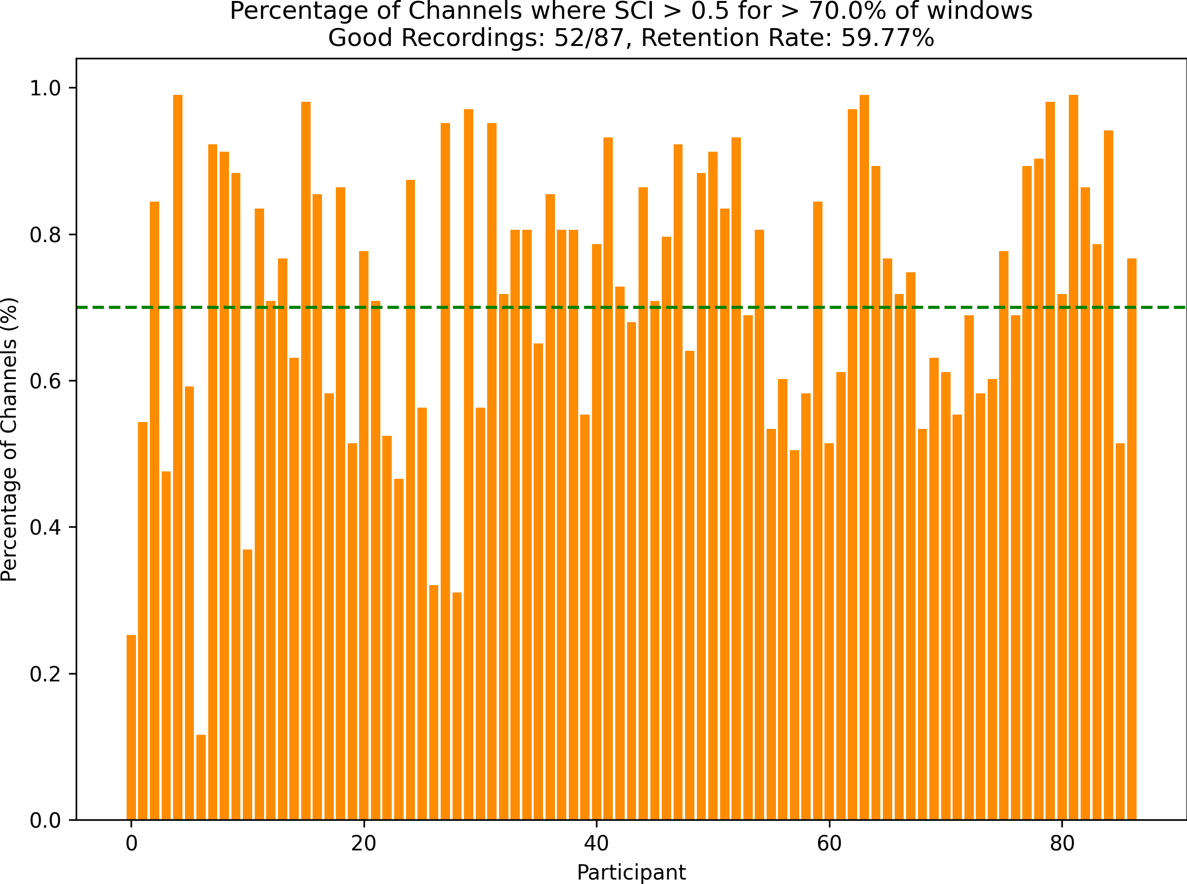

Figure 2.1: Percentage of Channels where SCI *>* 0.5 for *>* 70% of the windows. The green dashed line represents the threshold of 70% of windows that each participant must meet to be included in the analysis.

## Stimuli

Face stimuli were selected from two large publicly available repositories: the RADIATE dataset (Conley et al., 2018) and the UIBVFED dataset (Oliver and Amengual Alcover, 2020). The RADIATE dataset contains 109 images of racially and ethnically diverse real people, aged 18-30 years old expressing 16 emotions. The UIBVFED dataset contains a set of 20 virtual characters that are also ethnically diverse, aged 20-80 years old expressing

32 emotions. The UIBVFED faces were created (Oliver and Amengual Alcover, 2020) using blendshapes, a tool that represents and manipulates facial action units (Ekman and Friesen, 1978). The faces used in the current study were based on the following criteria:

1) 20 young adult models were selected, 5 males, 5 females from both datasets (RADIATE and UIBVFED), 2) The corresponding models from each dataset were matched for face shape, sex, skin tone, and hair color, and 3) 7 emotional expressions (anger, disgust, fear, happiness, sadness, surprise, neutral) were selected for each model, that closely align with Ekman’s 6 basic emotions + neutral (Ekman, 1992). The UIBVFED images were cropped to the same size as the RADIATE images, for consistency in the stimuli presentation. The stimuli presentation was prepared using PsychoPy3 Experiment Builder (v2024.1.5) (Peirce et al., 2019).

## Design and Procedure

### Procedure

The stimuli were presented on a Dell U2415 24 inch 1920x1200 60Hz monitor, placed at eye level, and the participants were seated in a comfortable chair facing the monitor. The beginning of the stimuli presentation had instructions on the screen, which explained the task to the participant, and the participant entered the space bar when they were ready to start the experiment. We used a repeated-measures design consisting of four within- subjects factors: 1) Face Type (Real, Virtual), 2) Emotion (Anger, Disgust, Fear, Joy, Sadness, Surprise, Neutral), 3) Model (10 unique identities per face type), and Sex (Male, Female). Each participant saw 28 repetitions of each Face Type, 8 repetitions of each emotion across 56 blocks, each comprising eight faces (4 male, 4 female) of the same face type and emotional expression, counterbalanced across Face Type and Emotion. Between every block and starting the experiment, there is a fixation cross presented for 16 seconds. The 8 faces (4 male, 4 female, randomly selected) are presented one at a time, for 1.5

seconds each, with a 250-750 ms (mean 500 ms) interstimulus interval (ISI) between each face. To ensure participants remained engaged and focused on the emotions and faces, they also completed a memory task at the end of each block. That is, participants saw blocks of 8 faces, and after each block, there will be a 9th face, and they will need to indicate whether the 9th face was in the previous block of 8 faces. The participant was instructed to press ’y’ on the keyboard if the face was in the previous block, or ’n’ if the face was not in the previous block. The 9th face has a 50% chance of either being in the previous block or not, and if the participant does not respond within 7 seconds, the presentation will continue to the next block. Every 7 blocks, the participants are given a break, and prompted to enter the space bar when they are ready to continue the experiment. This task is visualized in Figure 2.2.

Brain activity was recorded using Aurora fNIRS while participants completed the task. Head size was measured and an fNIRS cap was fitted to their head. A signal optimization routine (in Aurora fNIRS) then increases the source brightness in a stepwise manner, until the optimal signal levels for all channels is reached. The signal level is the voltage reading at a detector optode, which reflects how well light passes through the tissue from a source optode to a detector optode. Participants were told that a series of faces each expressing different emotions would appear one at at time on the screen, and at the end of each block they would be asked whether a probe face matched one of the faces they saw in during the block they just completed. The experimenter(s) then turned the lights off in the room to avoid any interference with the fNIRS cap. Then the experimenter(s) started the experiment, and left the room to minimize noise and distractions. Experimenter(s) then monitored the experiment from outside the room, using a camera in the testing room. After the experiment was completed (approximately 35 minutes), the experimenter(s) entered the room, removed the fNIRS cap, and the participant was debriefed about the experiment.

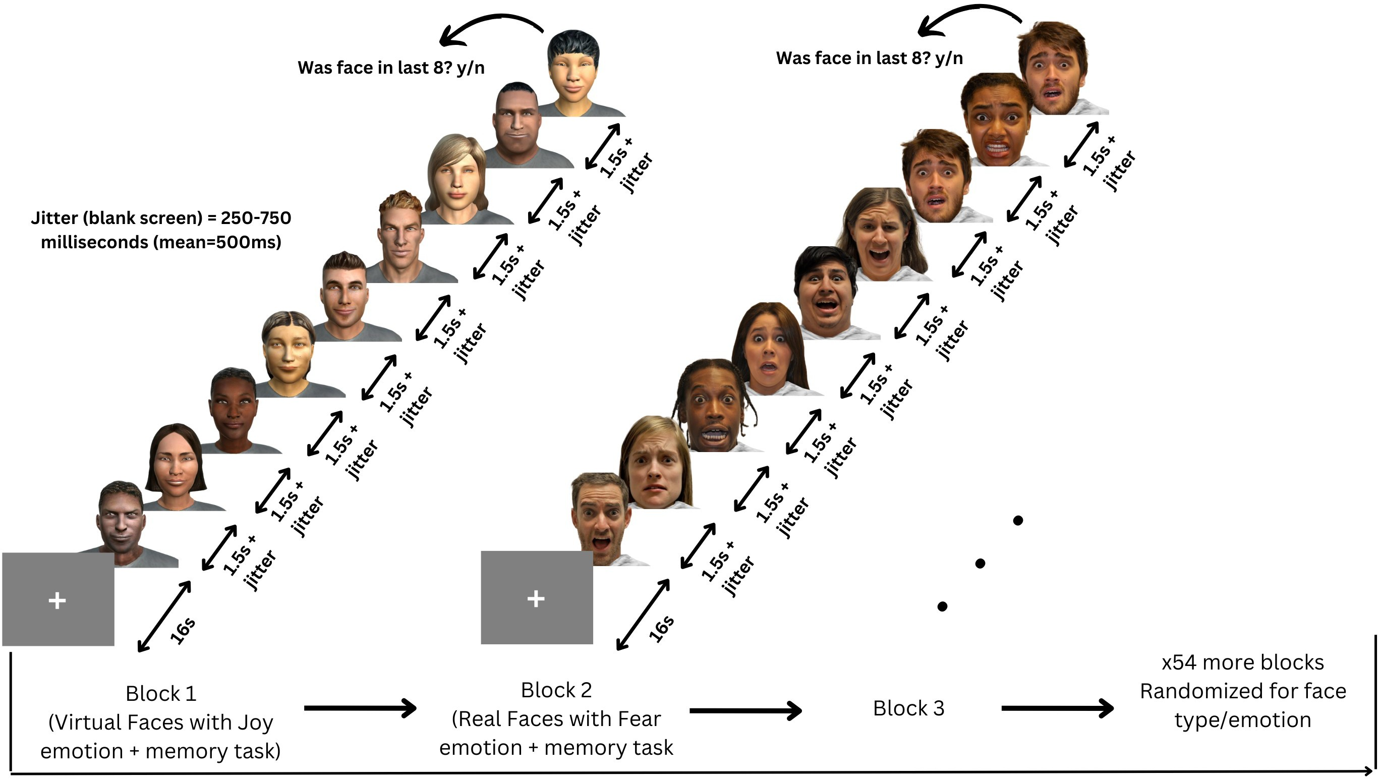

Figure 2.2: Participants viewed 56 blocks of 8 faces, each block being either all real or all virtual faces. Every face in a block displayed the same emotional expression, one of: anger, disgust, fear, happiness, sadness, surprise, neutral.

## fNIRS data

fNIRS data was collected using two NIRSport2 systems (NIRx Medical Technologies, Berlin, Germany). Each NIRSport2 system was equipped with 16 source and 16 detector optodes, and daisy-chained together for a high density 32x32 optode configuration. Each neighboring pair of source and detector optode is referred to as a channel, resulting in a total of 103 HbO + 103 HbR channels (plus 16 short distance channels). The average distance between source and detector optodes was 30 mm, and 7mm for short distance channels, which were placed on a flexible fNIRS head cap (NIRScap) 58 cm in circumference. The optodes were arranged in a high density 32x32 montage with one bundle of short distance channels, as shown in Figure 2.3. This montage was designed to cover a maximally large area of the brain, given increasing evidence that emotion processing is not localized to specific discrete areas of the brain, rather distributed across

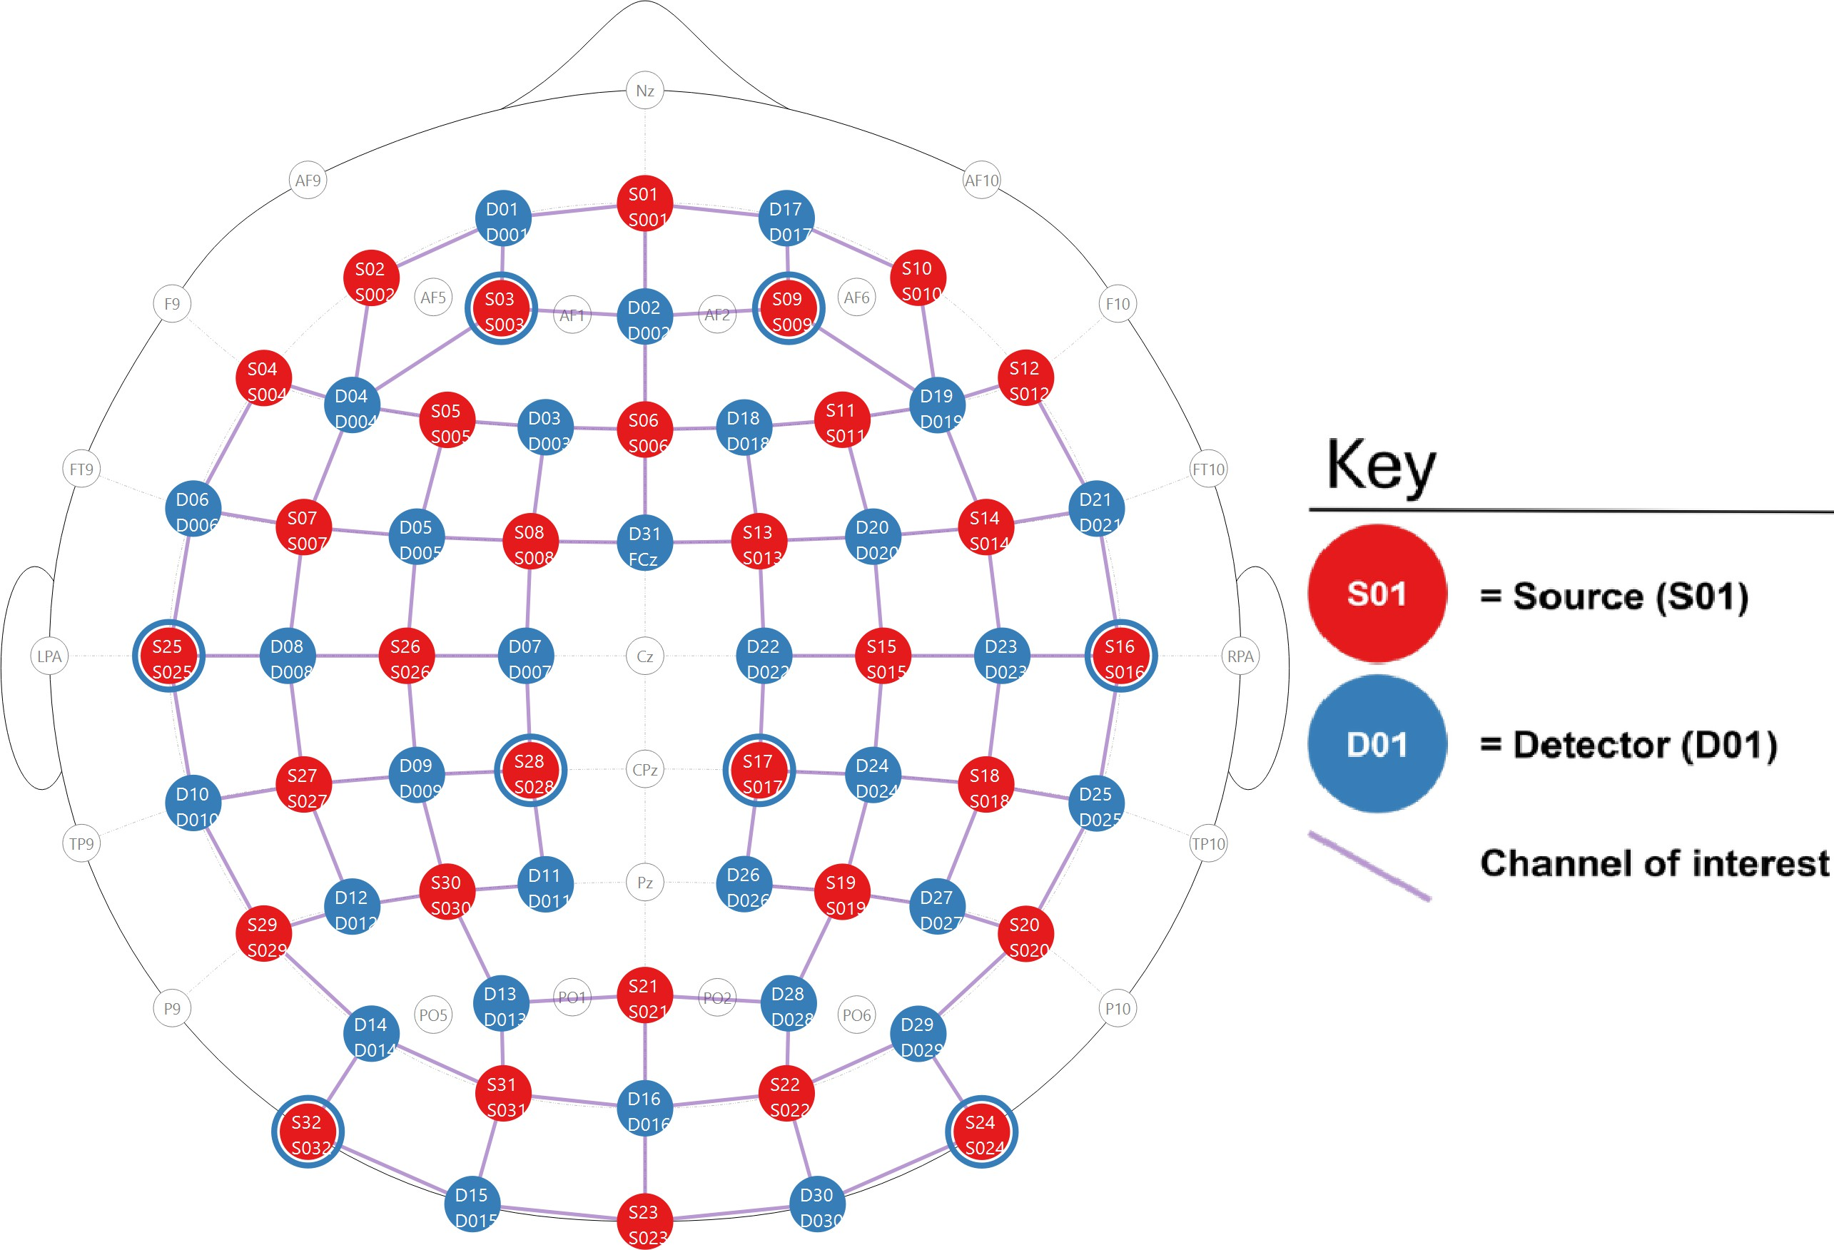the brain (Lindquist et al., 2012). The fNIRS cap and optodes were positioned following the 10-20 international coordinate system. Light was emitted at 760 nm and 850 nm wavelengths, and the sampling rate was approximately 6.105 Hz.

1. 2D depiction of the montage.

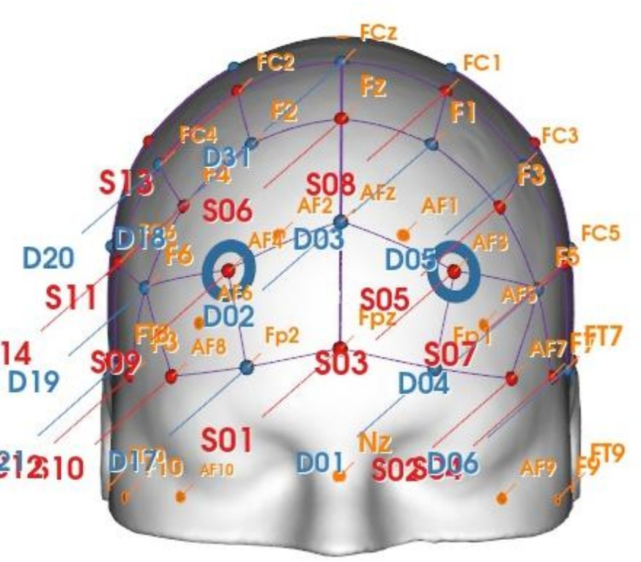 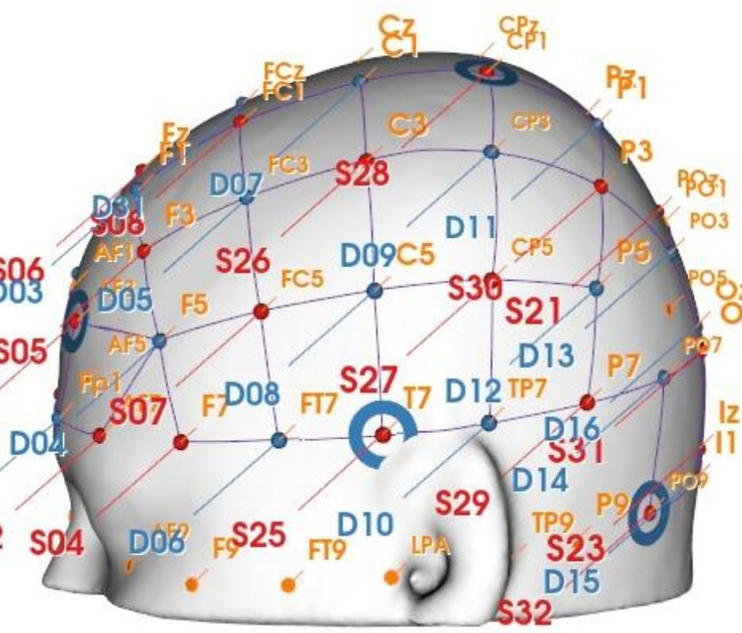

1. 3D front view of the montage. (c) 3D side view of the montage.

Figure 2.3: Depictions of the high density 32x32 optode montage. Red circles represent sources, blue circles represent detectors, purple lines represent channels, and blue rings around sources represent the locations of the 8 short distance detectors.

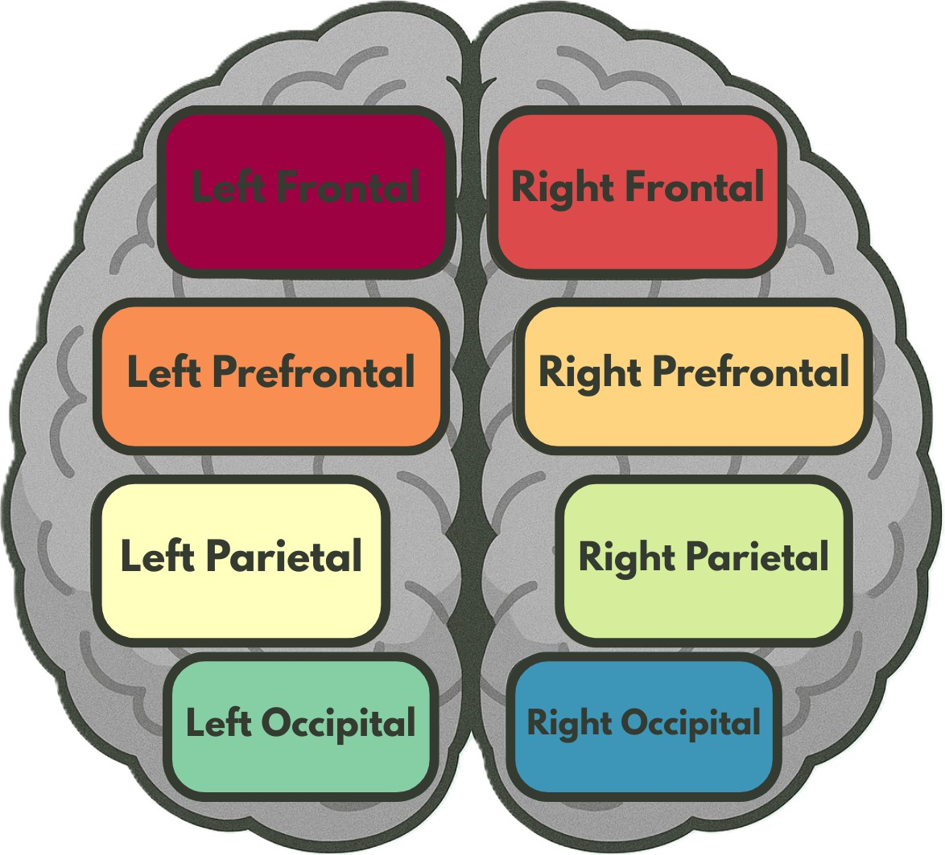

Figure 2.4: Brain region map, showing the regions of interest (ROI’s) that the channels were grouped into for certain analyses.

## Analysis

All fNIRS data was preprocessed and analyzed with Python 3.11.9 using MNE (version 1.9.0) (Gramfort et al., 2013) and MNE-NIRS (version 0.7.1) (Luke et al., 2021), which used the Nilearn package (version 0.9.2). First, the General Linear Model (GLM) analysis was performed, followed by a functional connectivity analysis performed on the same set of data. The memory task was analyzed on the y/n responses discussed in 2.3.1.

### Preprocessing Steps

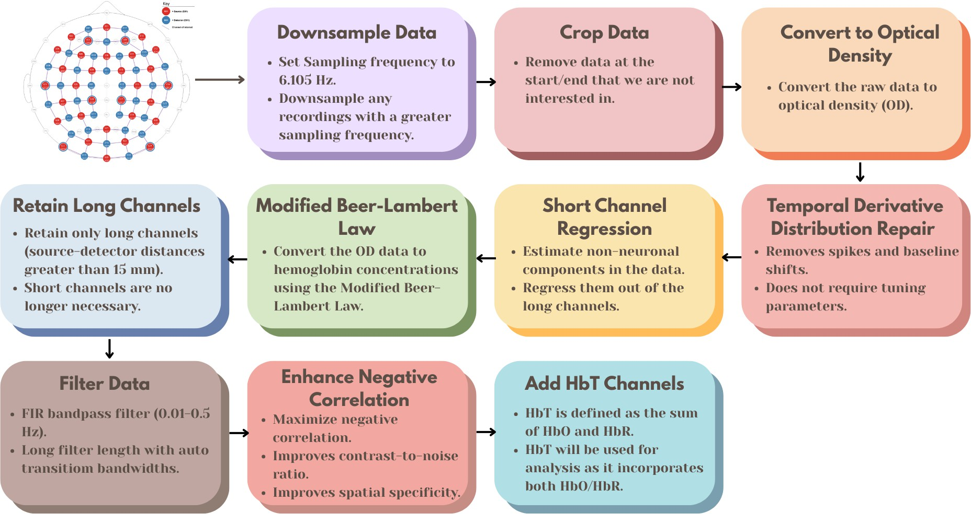

Figure 2.5: Preprocessing steps for fNIRS data, from the raw data to the fully processed data.

The preprocessing steps for the fNIRS data, as shown in Figure 2.5, were as follows:

1) Downsample the data if the sampling frequency is greater than 6.105 Hz, the initial two datasets were sampled higher than 6.105 Hz, and the sampling frequency should be consistent across all datasets. 2) Crop the data to the first and last annotation. This gets rid of the extra data at the beginning and end of the recording that are not of interest. 3) Convert the raw data to optical density. 4) Apply temporal derivative distribution repair to the OD data (Fishburn et al., 2019). TDDR is effective at removing spikes and baseline shifts from the data. 5) Apply short channel regression to the OD data (Scholkmann et al., 2014). Short channels are used to estimate the superficial hemodynamics (non- evoked/extracerebral/systemic components) in the data, and then regress it out of the long channels (Tachtsidis and Scholkmann, 2016). 6) Convert the OD data to hemoglobin concentrations using the modified Beer-Lambert law. The MBLL relates the change in light attenuation to the change in hemoglobin concentration of chromophores in the

tissue (Kocsis et al., 2006). 7) Retain only long channels (source-detector distance *>* 15 mm). Since the short channels have already been regressed out, it is no longer necessary to keep them in the data. 8) This FIR bandpass filter extracts signal components in the 0.01-0.5 Hz range, it uses a long filter length (2015 samples) with automatically determined transition bandwidths by MNE-Python (Pinti et al., 2019). 9) Maximizes negative correlation between HbO and HbR (Cui et al., 2010). This method removes spikes, improves contrast-to-noise ratio, and improves spatial specificity of the data. 10) Add HbT (hemoglobin total) channels to the data. HbT is defined as the sum of HbO and HbR. Often, fNIRS studies will only use either one of HbO or HbR channels (more frequently HbO), leaving out one channel with no justification (Kinder et al., 2022). Therefore, HbT channels are chosen, as HbT makes use of both HbO and HbR channels, and using both hemoglobin species improves the inferences as to where activation occurs Hocke et al. (2018).

### Epochs

Variable length epochs were created for each block of 8 faces, which were 14-18 seconds long (mean = 16s), depending on the ISI’s (see 2.3.1). Epochs were sorted by Face Type (Real, Virtual), and Emotion (Anger, Disgust, Fear, Happiness, Sadness, Surprise, Neutral). Baseline correction was applied to remove any constant or slowly varying offsets in the data. The data was annotated with the onsets and offsets of each block, along with the duration and condition of each block for use in section 2.5.3 and 2.5.4.

### General Linear Model (GLM) Analysis

The General Linear Model (GLM) posits that the observed haemodynamic signal at each channel or Region of Interest (ROI) is a linear combination of task-related regressors convolved with a Hemodynamic Response Function (HRF), plus nuisance regressors (e.g., drift) and residual noise. Mathematically,

*Y* = *Xβ* + *ϵ,* (2.1)

where *Y* is the observed time series, *X* is the design matrix, *β* represents the pa- rameters to estimate, and *ϵ* denotes the residuals assumed to be (i.i.d.) Gaussian noise. Estimation is performed via ordinary least squares (OLS), yielding parameter estimates that quantify condition-specific activation amplitudes.

#### Design Matrix

For each of the epochs, events are defined by their trial type (e.g., emotion or face type), and onsets/offsets relative to the procedure start, and duration. The design matrix is constructed using Nilearn’s make first level design matrix by convolving a boxcar function (based on the event timing) with a canonical HRF, which is a model of the expected haemodynamic response to neural activity. The canonical HRF Statistical Parametric Mapping (SPM) (Friston, 2007) is chosen to model neurovascular coupling, this model captures the stereotypical rise and fall of the BOLD/fNIRS response. The cosine drift model was utilized, which incorporates discrete cosine transform (DCT) basis functions into the design matrix to model and remove low-frequency drifts. The selection of the high pass cutoff frequency is guided by the structure of the experimental design. The cutoff period is set to twice the duration of the longest inter-trial interval, and each fixation period between epochs (or blocks) is 16 seconds. Therefore, a cutoff period of 32 seconds (i.e., high pass=0.03125 Hz) would be appropriate. This ensures that the drift model does not remove task-related signal components that occur at frequencies higher than the cutoff (Luke et al., 2021). The design matrix *X* and preprocessed time series are fed into MNE’s run glm function, which computes OLS estimates of *β* for each channel.

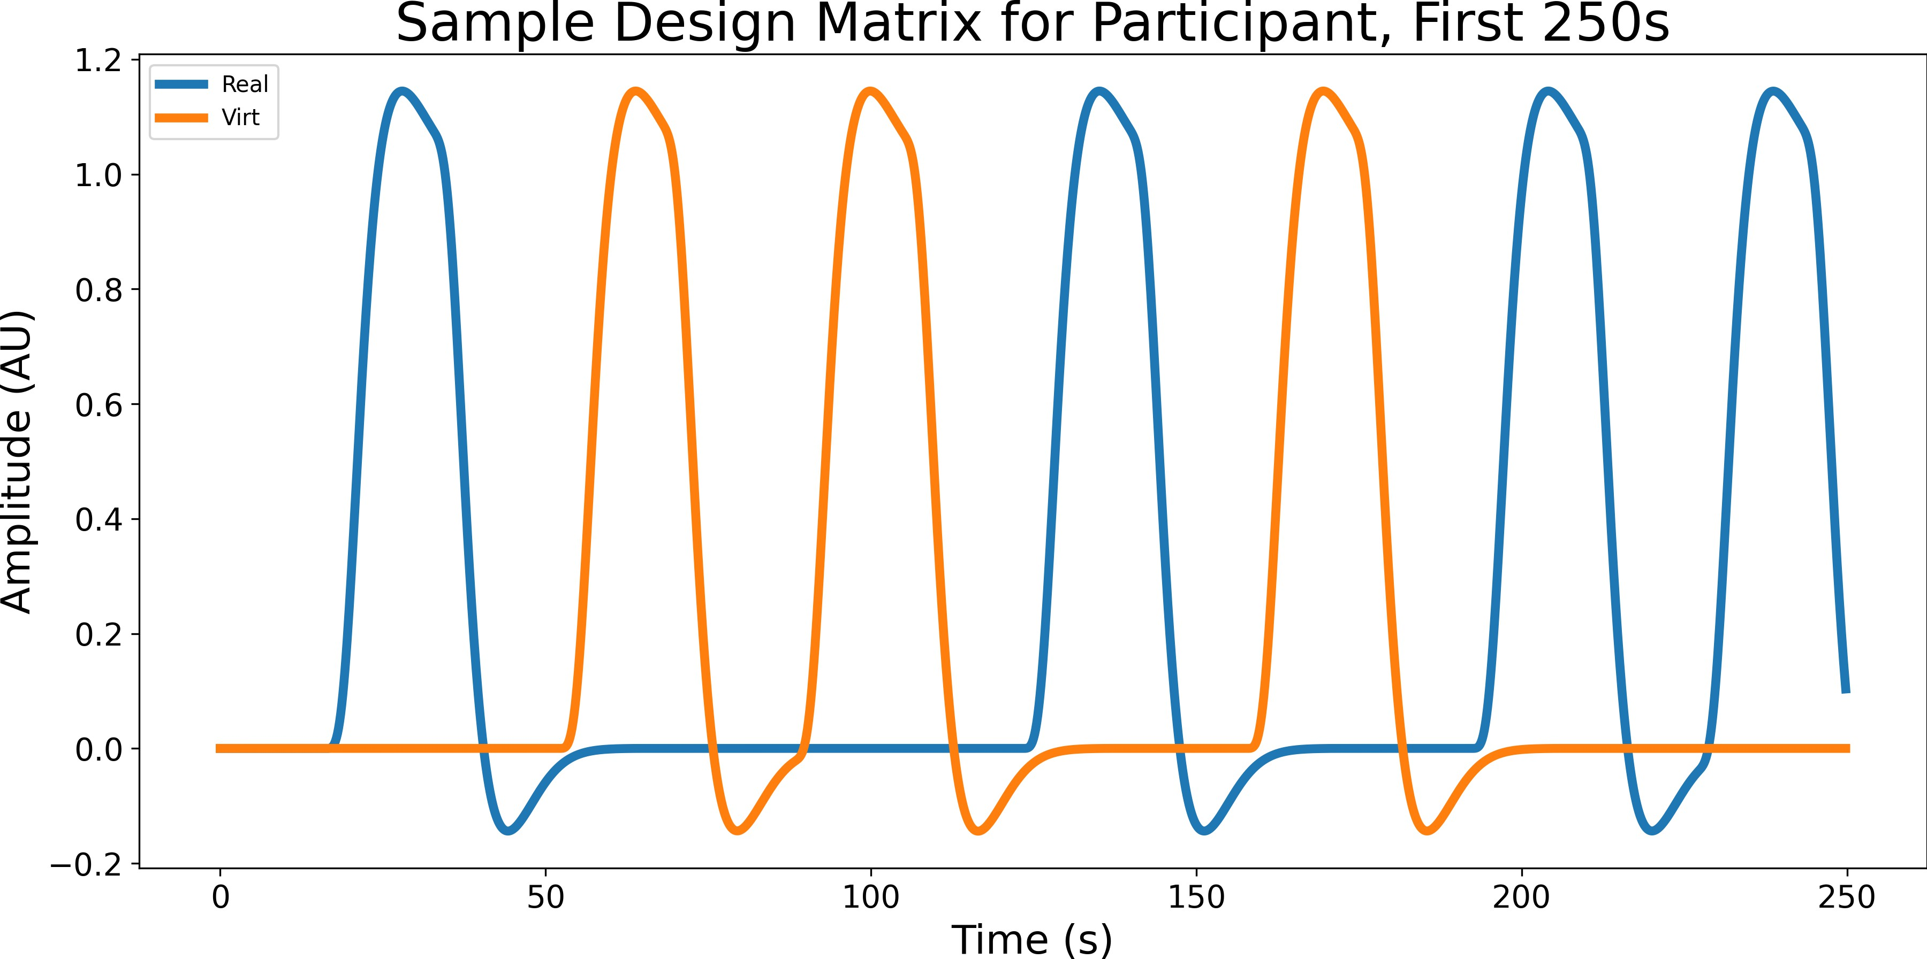

Figure 2.6: Sample design matrix for a single participant for the effect Face type, showing the first 7 blocks (250 seconds) of a single experiment. The design matrix is organized by condition (Blue for real, orange for virtual), this is the result of convolving the boxcar function with the canonical HRF SPM.

#### Contrast Computation

All pairwise contrasts were generated between conditions by constructing an identity con- trast matrix over design columns. For each pair of conditions (*A, B*), the contrast vector is defined as: *c* = *eA − eB*, where *eA* and *eB* are the respective design matrix columns for conditions *A* and *B*. Contrasts are computed using MNE’s compute contrast function, which produces effect estimates and test statistics aggregated across channels. Since numerous statistical tests are performed across channels and contrasts, *p*-values were corrected for false discovery rate (FDR) using the Benjamini-Hochberg procedure (Singh and Dan, 2006) with a family-wise error rate of *α*=0.05.

### Functional Connectivity Analysis

To characterize the temporal coordination between fNIRS channels during face and emotion processing, functional connectivity matrices were computed using a continuous

wavelet transform (CWT)-based spectral connectivity approach. CWT decomposes sig- nals into simultaneous time-frequency representations, providing an optimal framework for fNIRS connectivity analysis by accommodating the non-stationary, physiological na- ture of hemodynamic signals. The morlet wavelet, a gaussian function modulated by a sine wave, was picked as they are suited to capture both slow neural rhythms and faster systemic fluctuations in fNIRS data (Reddy et al., 2021). Wavelet-based approaches have been widely adopted in the fNIRS literature for connectivity and even artifact correction (Bergmann et al., 2023; Hakim et al., 2023) Coherence combines both phase and ampli- tude information into a single, normalized index, 0 (no coupling) to 1 (perfect coupling), and is a richer description of coupling than phase-only or amplitude-only metrics (Bastos and Schoffelen, 2016). For each participant, MNE’s spectral connectivity time func- tion was applied to compute time-resolved coherence across pairs of channels, the average of this was taken across epochs to obtain a single channel-by-channel connectivity ma- trix for each condition. Each participants’ connectivity matrix was then averaged across participants to obtain a group-level connectivity matrix for each condition, an example of a group-level connectivity chord plot is shown in Figure 2.7. fNIRS hemodynamics predominantly fluctuate in very low frequencies (0.01-0.5 Hz) (Reddy et al., 2021). The frequency range was narrowed to five evenly spaced frequences between 0.2-0.5 Hz due to short epoch length, this range still targets systemic and neurogenic oscillations while avoiding high-frequency noise (Xu et al., 2017). Averaging across these closely spaced fre- quencies reduces data dimensionality, simplifying downstream statistical analyses without sacrificing sensitivity to coupling dynamics.

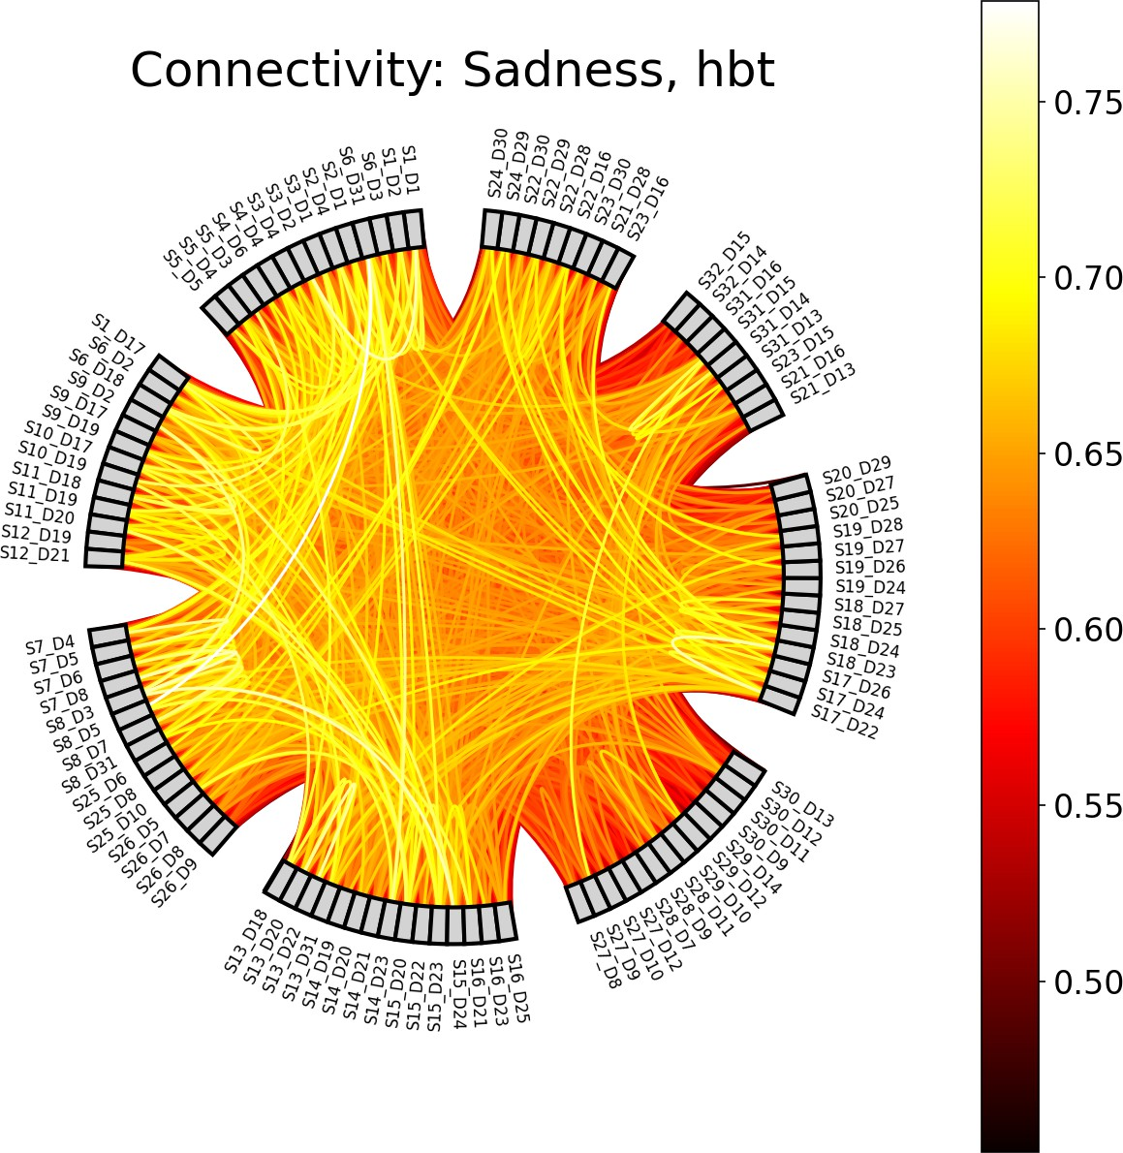

Figure 2.7: Example of a chord plot for the condition Sadness, showing the averaged connectivity across participants and epochs between 103 HbT channels (coherence values between 0 and 1). The color of the lines represents the coherence value. In general, the brighter the color, the stronger the connectivity between the two channels.

#### Paired Sample t-tests

For each mode (Face type/Emotion), and pair of conditions (e.g., Joy vs. Fear), individual- level connectivity matrices were extracted, averaging across epochs and time points to obtain, per participant, a symmetric channel-by-channel coherence matrix. Because co-

herence values are bounded between 0 and 1 and exhibit skewed distributions (Miranda de S´a et al., 2009), Fisher’s r-to-z transform (atanh) was applied to each matrix element to normalize the data prior to parametric testing. Paired t-tests for each unique channel pair (*i > j*) were then conducted across participants using SciPy’s ttest rel. This di- rectly tests whether mean connectivity differs between conditions, leveraging the paired design to increase statistical sensitivity (Hu et al., 2023). Given the large number of channel-pair tests, and similar to the GLM analysis above in 2.5.3, *p*-values were cor- rected for FDR using the Benjamini-Hochberg procedure (Singh and Dan, 2006) with a family-wise error rate of *α*=0.05.

#### ROI Chord Plots

To distill high-dimensional channel-by-channel connectivity into interpretable inter-regional summaries, we mapped individual fNIRS channels onto anatomically defined ROI’s. This includes left and right frontal, prefrontal, parietal, occipital regions of the brain as shown in Figure 2.4, and the channels were grouped into these regions based on their location in the montage. Since multiple channels may map to the same pair of regions (e.g., several left prefrontal channels connecting to several right occipital channels), we aggregated all significant connections (*p <* 0.05) between two regions by taking the mean of their

t-values.

### Memory Task Analysis

Recall the memory task described in 2.3.1, where participants were asked to indicate whether the 9th face was in the previous block of 8 faces with a ’yes’ or ’no’ response on the keyboard. The memory task was not the main focus of the study, but it was used to keep the participants engaged and focused on the faces. However, one can investigate whether participants’ ability to correctly recognize or recall emotional facial expressions varied depending on the type of face (e.g., real vs. virtual) and the emotion

displayed (e.g., happy, sad, angry). Raw behavioral data files from the output of the PsychoPy presentation were systematically preprocessed to isolate key response variables. For example, if the participant pressed ’y’ for yes, and the 9th face was indeed in the previous block, they answered correctly, and if they pressed ’y’ for yes, and the 9th face was not in the previous block, they answered incorrectly. The same applies for the ’n’ for no responses. The total correct trials per participant were then summed. This data is not subject to the same signal quality criteria as the fNIRS data that was described in 2.1, as it is not a physiological measure. Therefore, all 87 participants can be included in the analysis, regardless of their fNIRS signal quality. However, participants achieving fewer correct responses than 34/56 (e.g., 60% of trials) were excluded to ensure sufficient engagement in the task, as shown in Figure 2.8. Only one participant was excluded from the analysis.

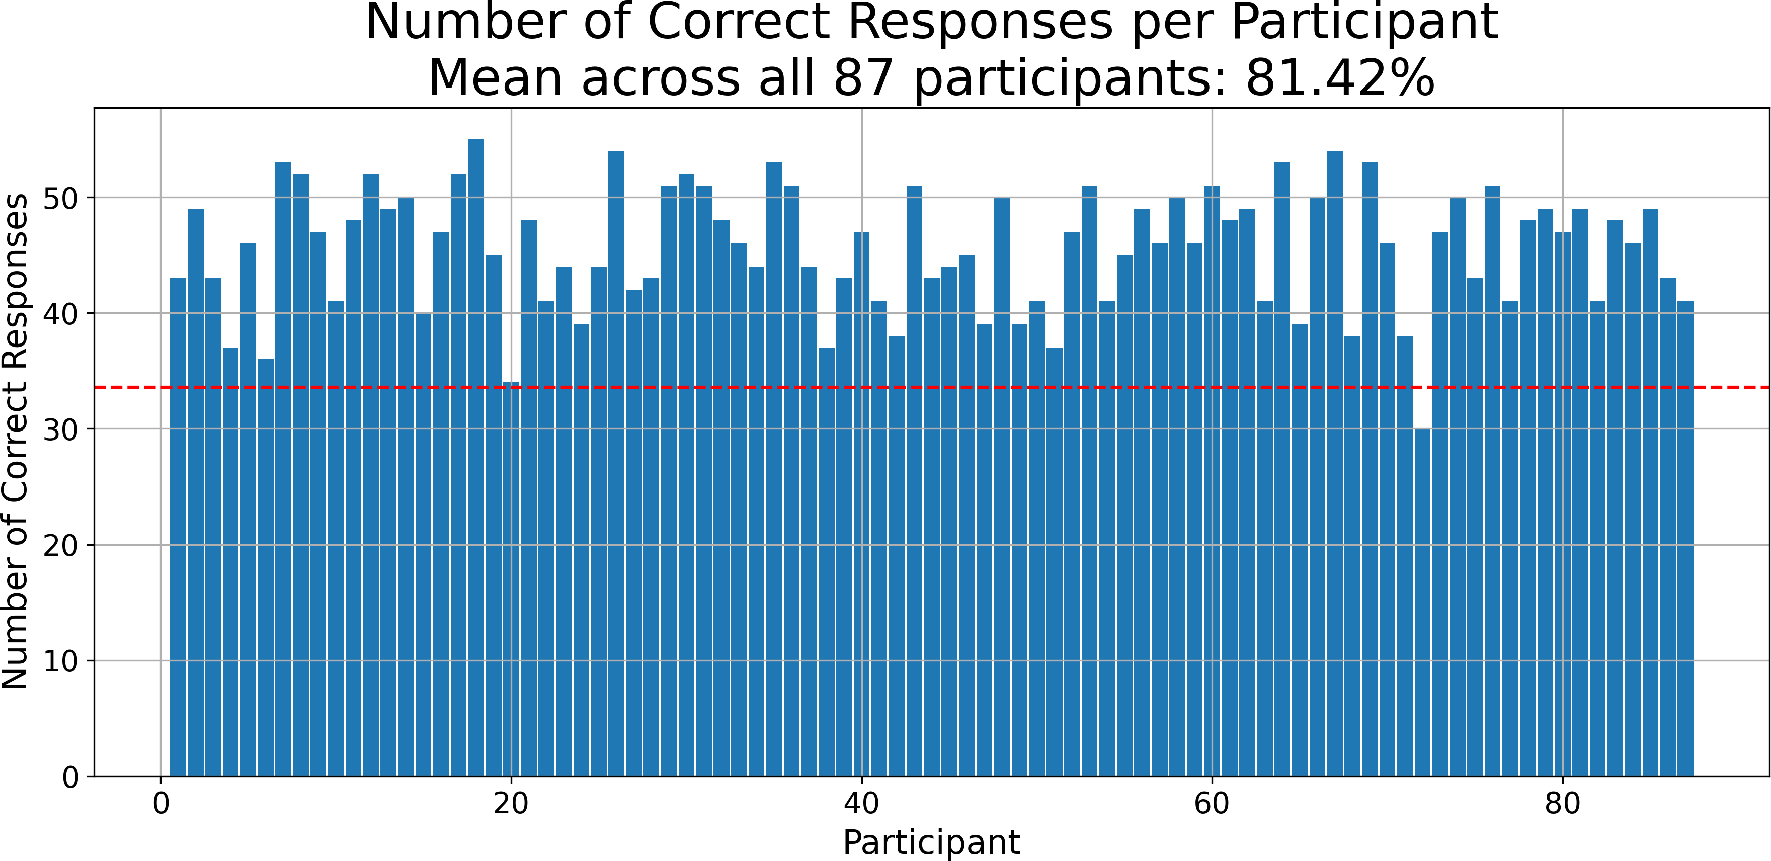

Figure 2.8: Number of correct responses by participant, the red dashed line represents the threshold of 34/56 correct responses (60%) that participants must meet to be included in the analysis. Only one participant was excluded from the analysis.

Since each block of faces was either all real or all virtual, and all had the same emotional expression (as discussed in 2.3.1), each y/n response was labeled with Face

type and Emotion. An OLS model was fit with accuracy (converted to numeric 0/1) as the dependent variable and categorical predictors for Face Type, Emotion, and their interaction. The goal is to determine the main effects of these two factors individually, as well as their interaction, on response accuracy. A two-way Type III ANOVA (via sm.stats.anova lm(model, typ=3)) provided *F* -statistics and *p*-values for main effects and interaction. This version of the ANOVA is especially suitable when interactions are included in the model, as it calculates each effect after accounting for all other terms.

# Chapter 3 Results

## General Linear Model (GLM) Results

### Face Type Contrasts

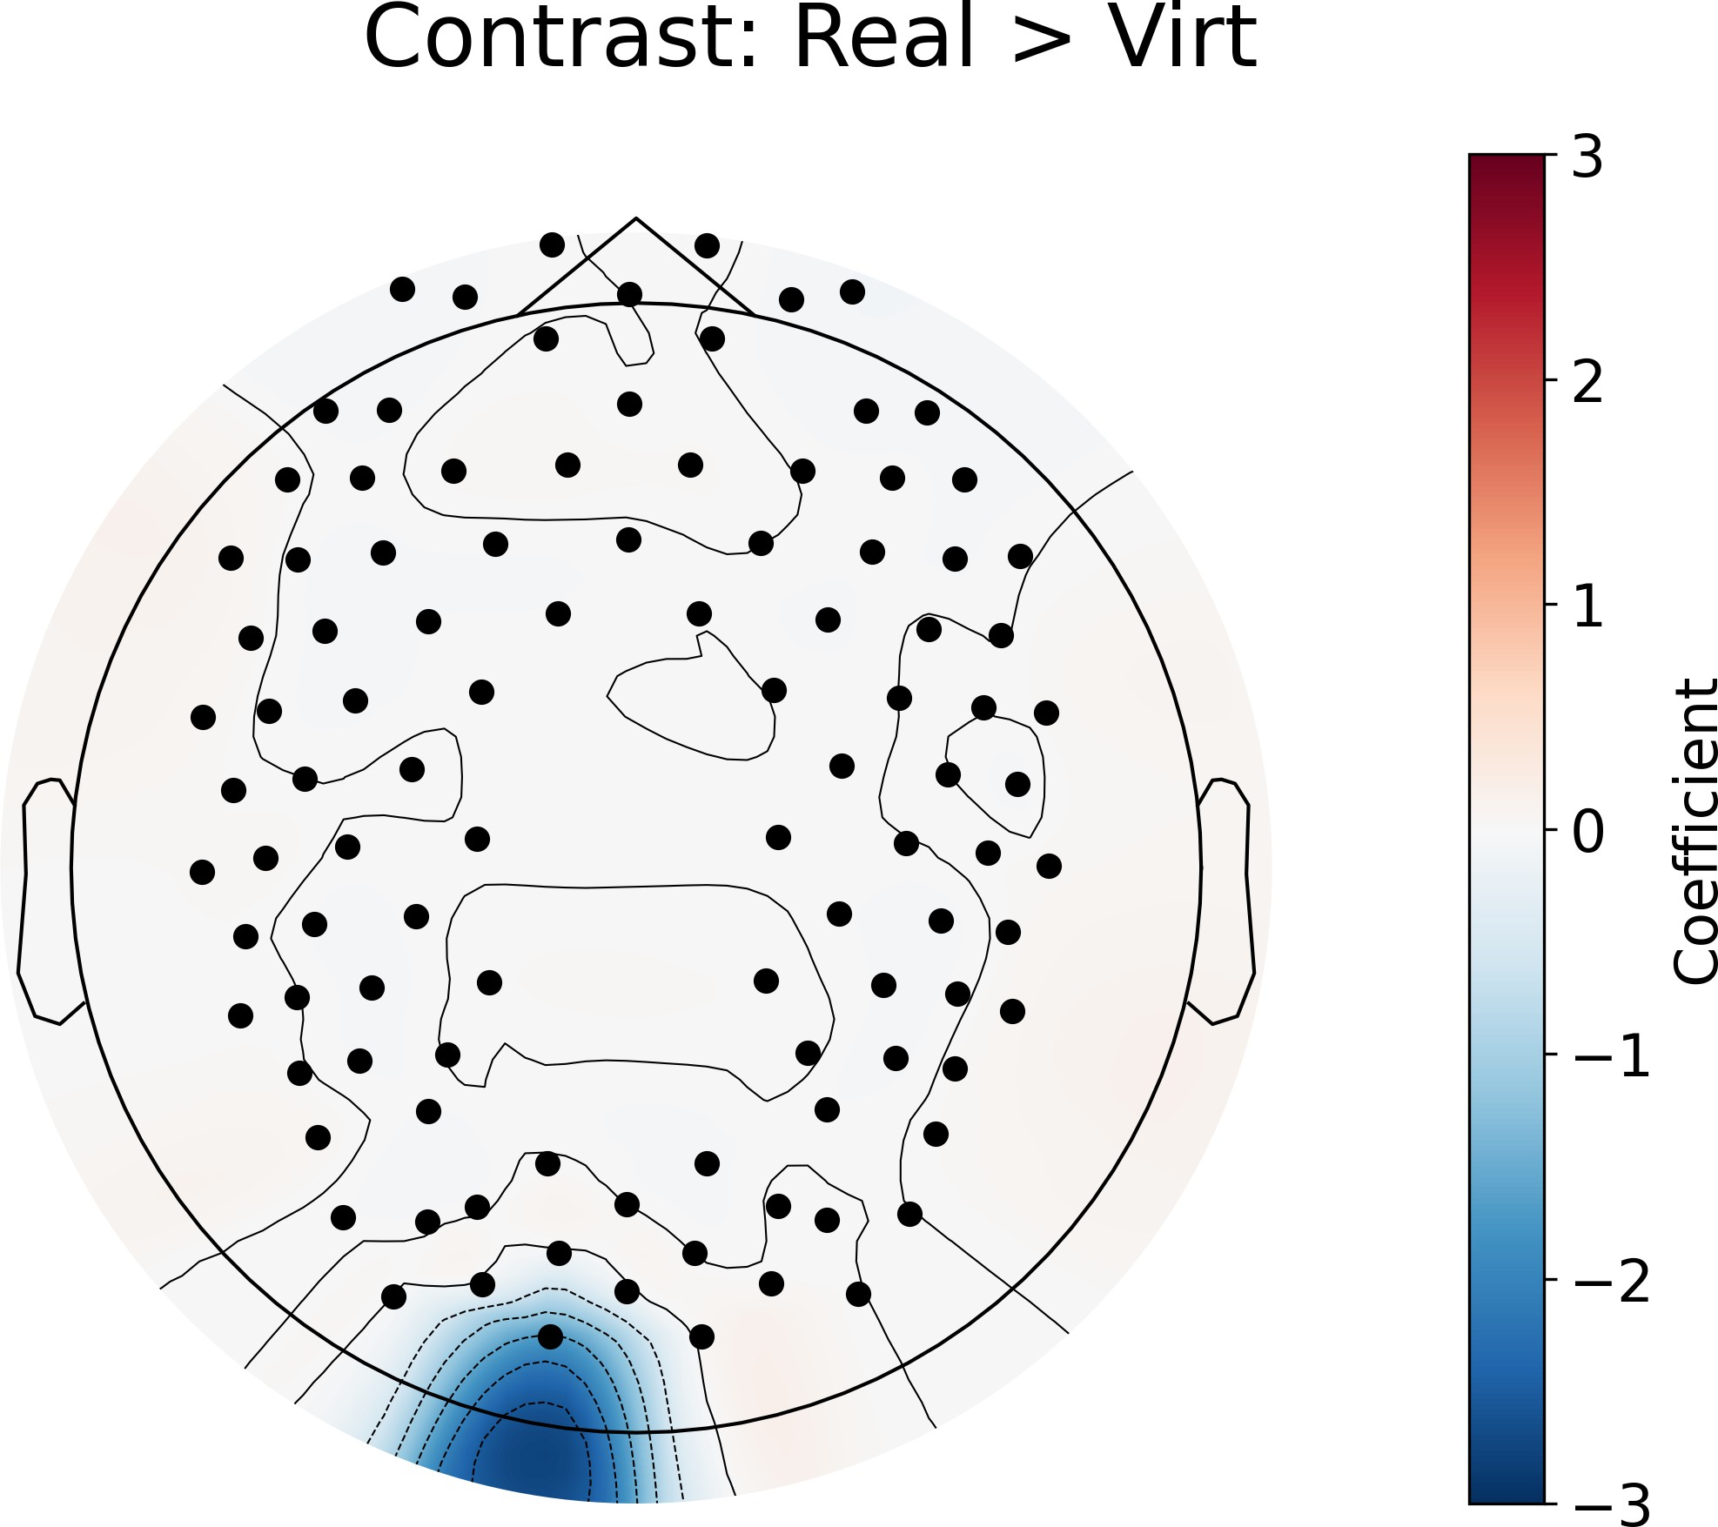

Figure 3.1: GLM contrast between real and virtual conditions which shows the differences in activation between the two conditions. Red signifies that condition 1 (real faces) has more activation in that area than condition 2 (virtual faces), while blue signifies that condition 2 (virtual faces) has more activation than condition 1 (real faces). The color bar on the right shows the coefficient of the contrast, which indicates the strength of the difference in activation between the two conditions.

18

The main effect of real versus virtual faces (as shown in 3.1) for the GLM revealed a significant difference in activation between real and virtual faces, with the left occipital channel showing greater activation for virtual faces compared to real faces.

### Emotion Contrasts

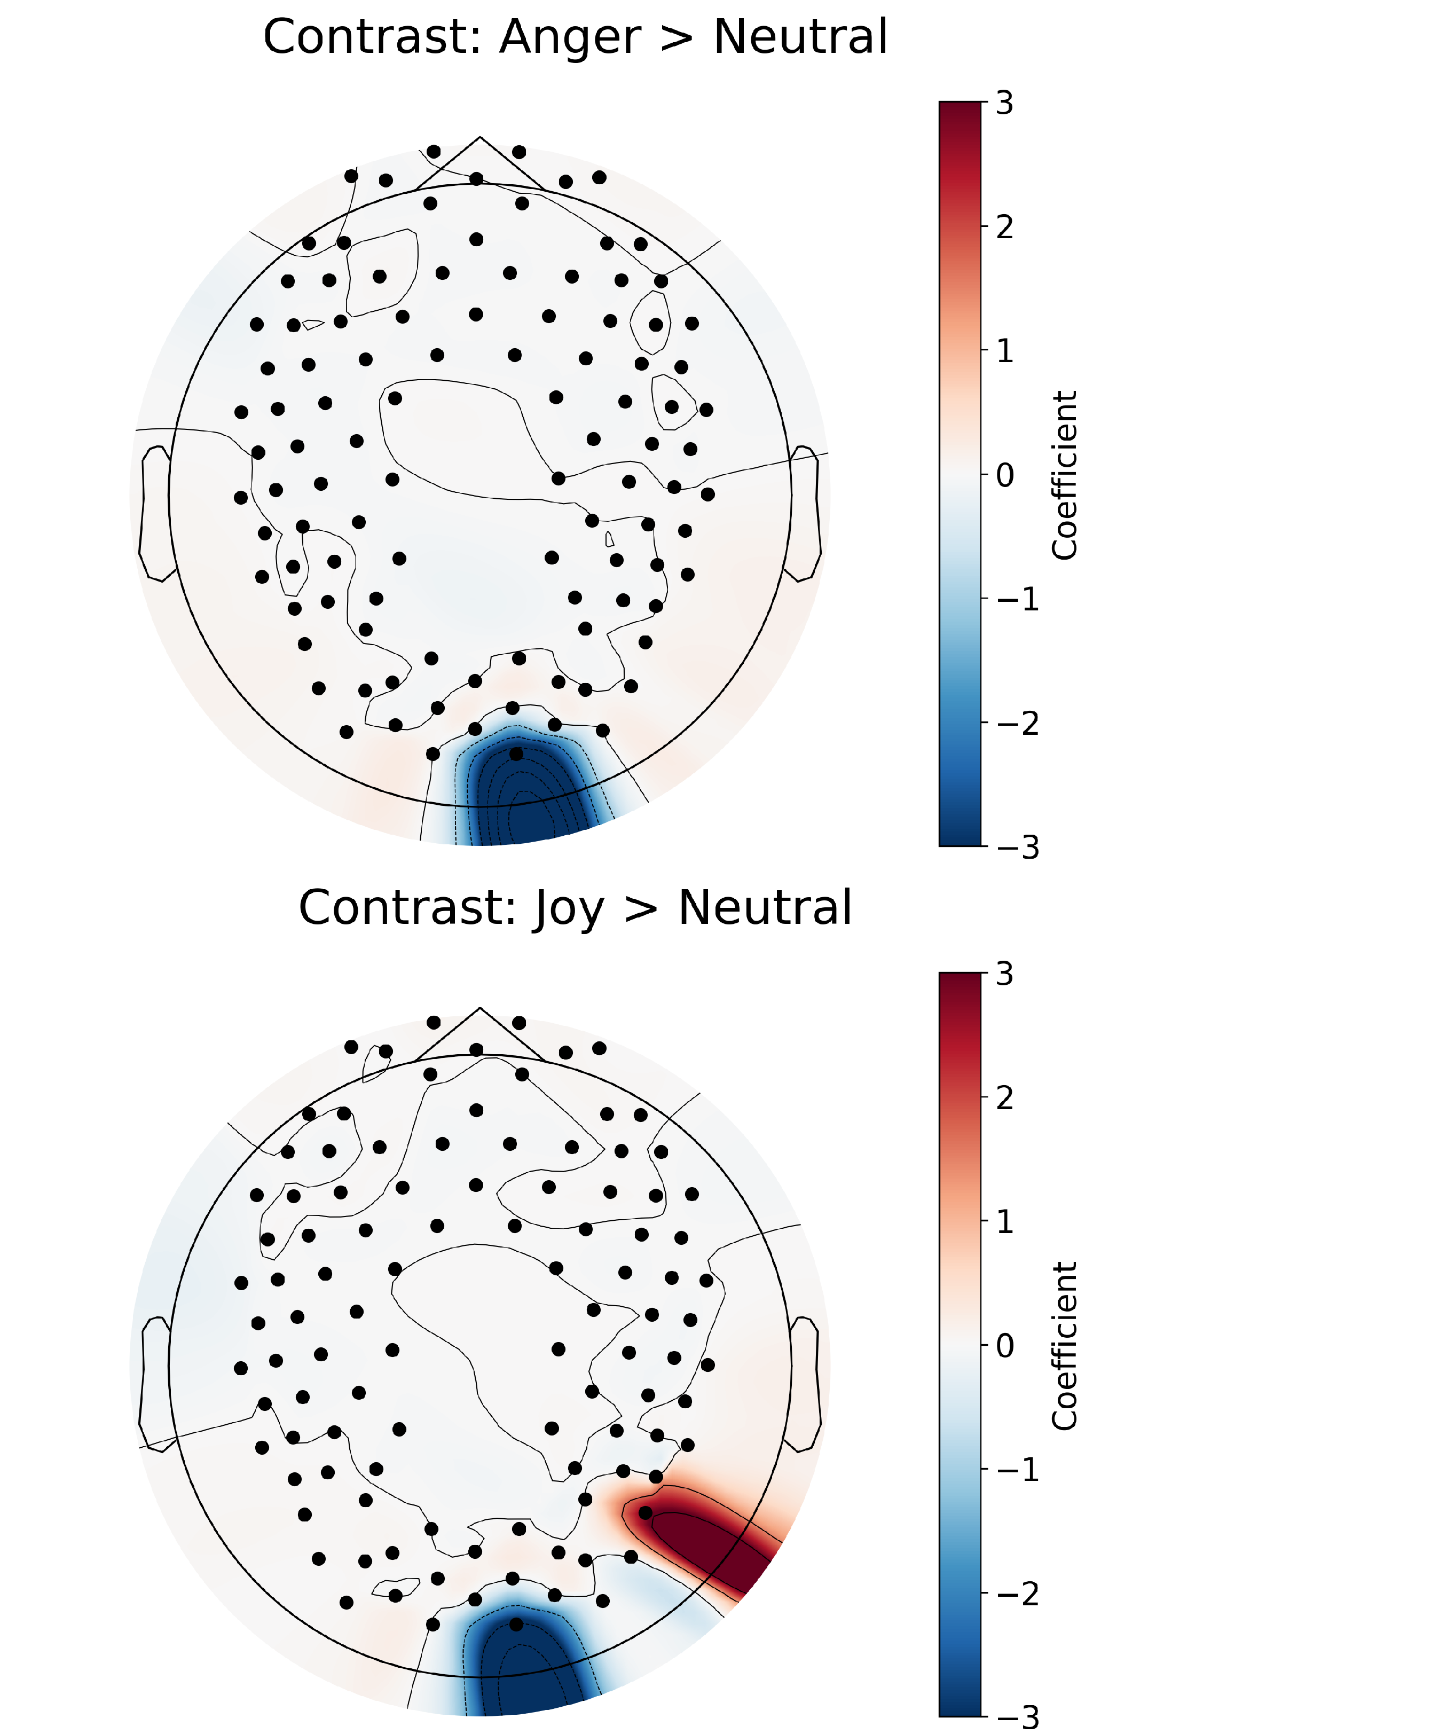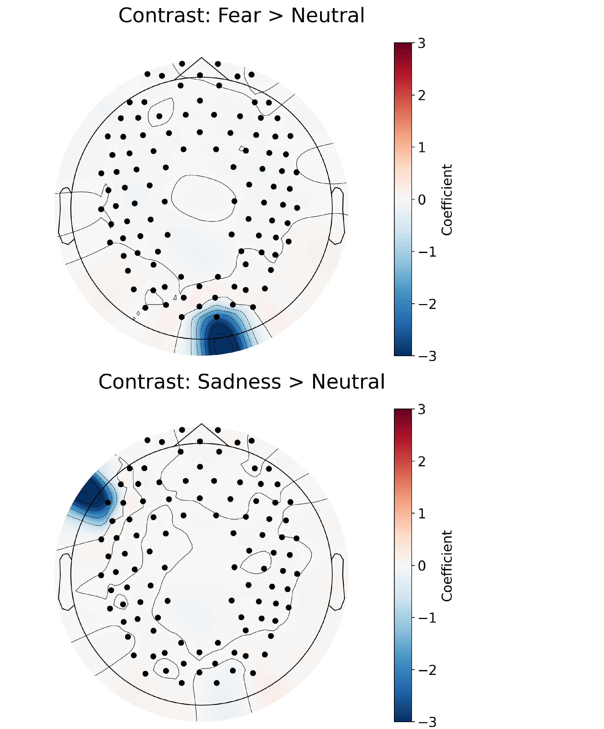

Figure 3.2: GLM results for the contrast between different emotions and neutral condi- tion. Same concept as explained in figure 3.1.

Against the Neutral emotion (as shown in 3.2), the emotion contrasts revealed significant differences in activation across several brain regions. Specifically, Anger and Fear elicited greater activation in the right occipital region compared to Neutral. Joy was associated with increased activation in the right parietal region and decreased activation in the right occipital region, while sadness showed reduced activation in the left frontal region relative to Neutral. These results indicate distinct neural activation patterns for each emotion when contrasted with the Neutral baseline.

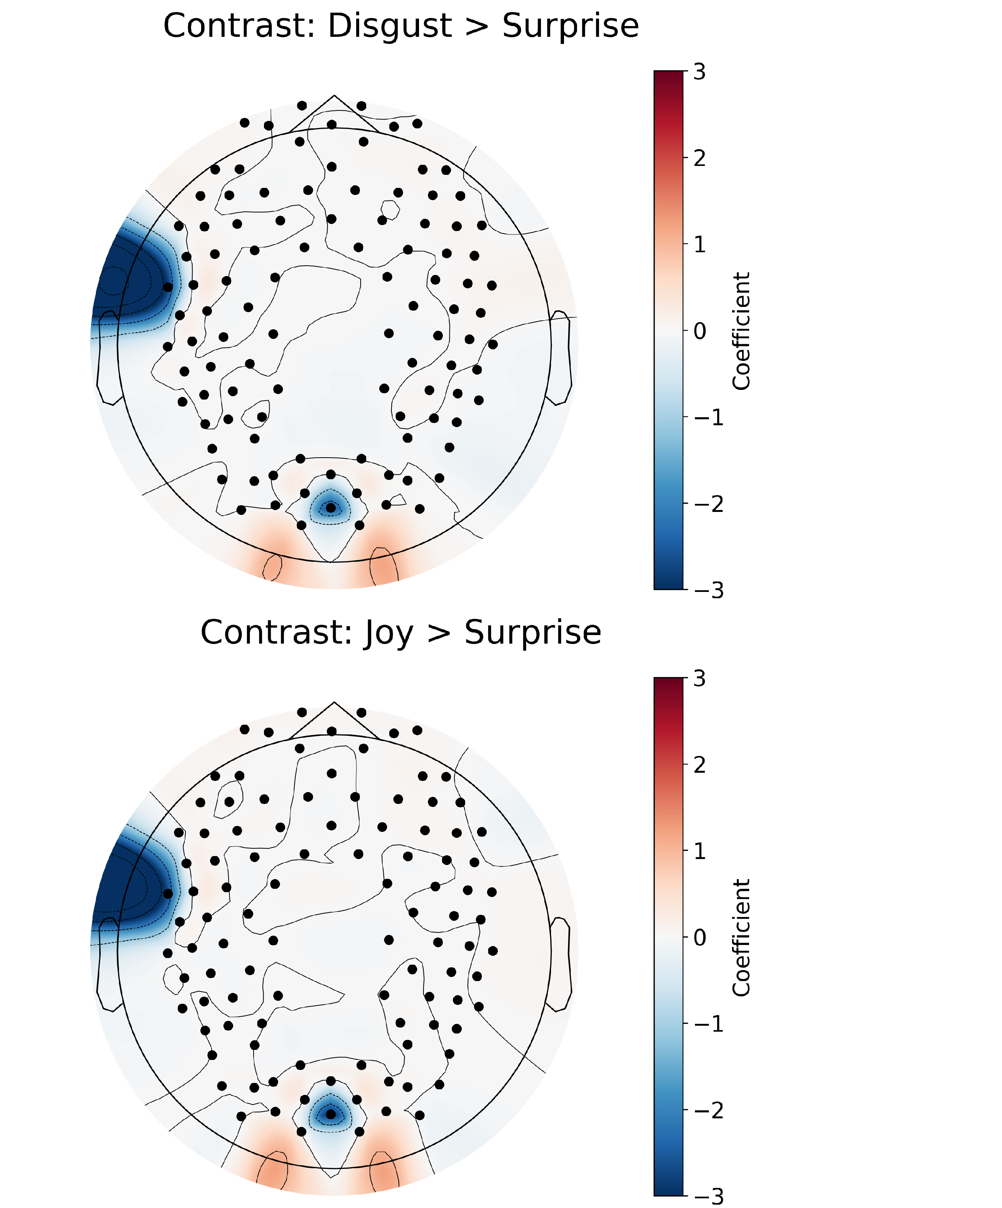 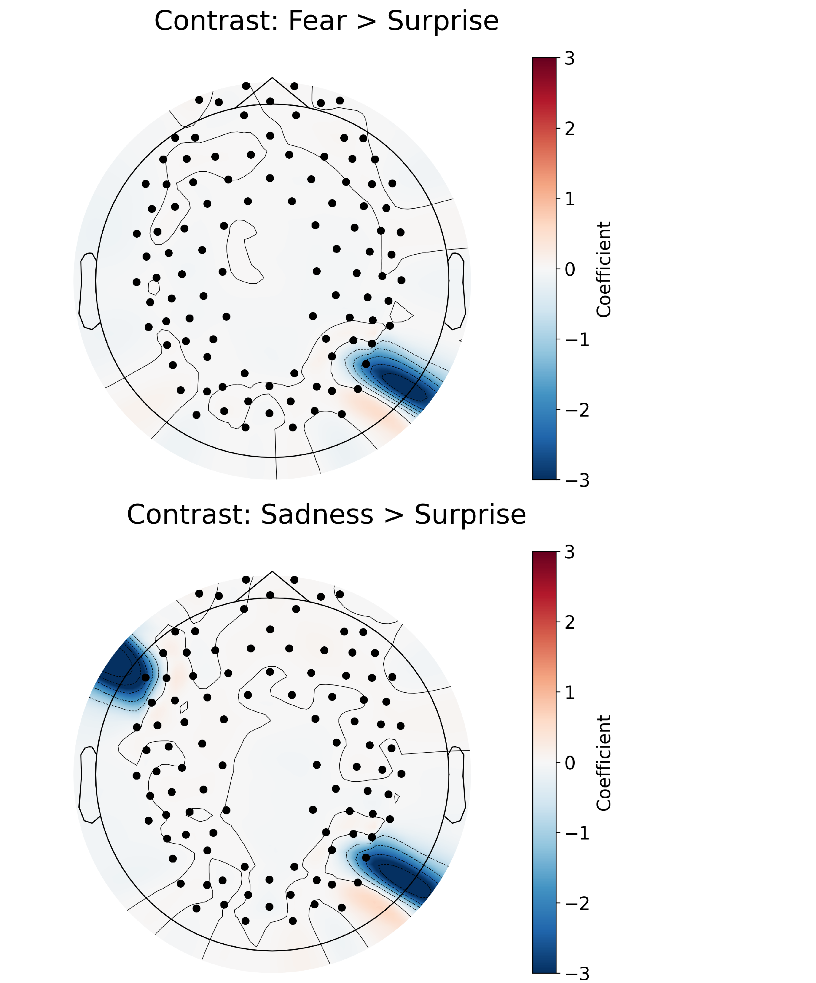

Figure 3.3: GLM results for the contrast between different emotions and surprise condi- tion. Same concept as explained in figure 3.1.

When comparing each emotion against Surprise (as shown in 3.3), significant differ- ences in activation were observed across multiple brain regions. Disgust and Joy both showed decreased activation in the right occipital and left prefrontal regions relative to Surprise. Fear was associated with reduced activation in the right parietal region, while Sadness showed decreased activation in both the left frontal and right parietal regions. These findings suggest that each emotion, when contrasted with Surprise, elicits dis- tinct neural activation patterns all across the brain, rather than being limited to specific regions.

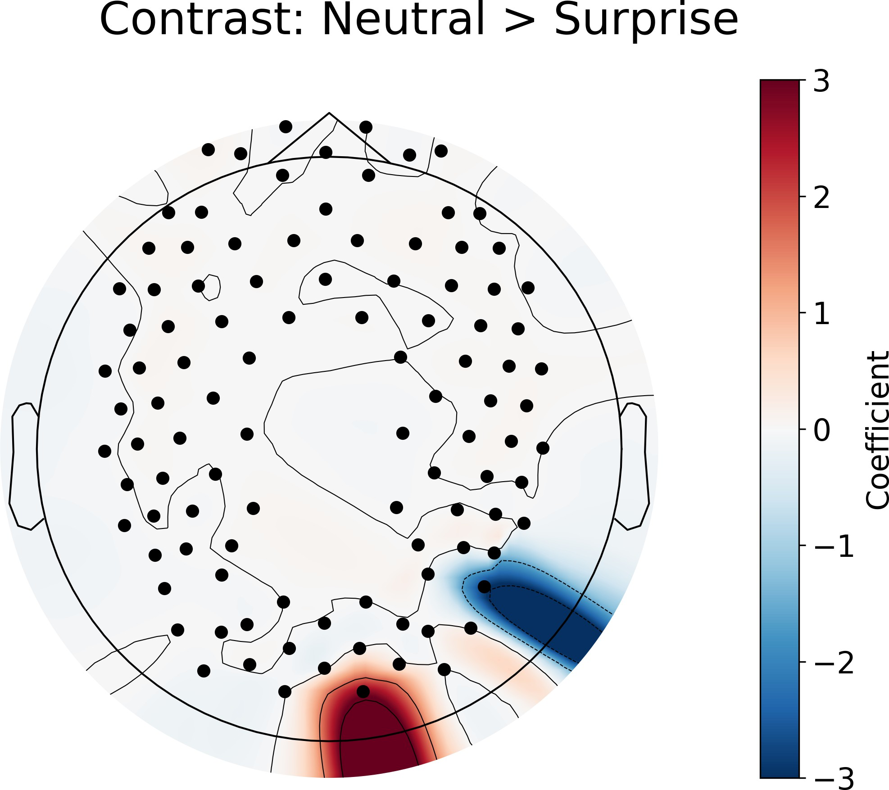

Figure 3.4: GLM results for the contrast between neutral and surprise condition. Same concept as explained in figure 3.1.

The Neutral *>* Surprise comparison (as shown in 3.4) revealed significant differences in the right parietal and right occipital regions. The right parietal region showed decreased activation (more activation for Surprise) while the right occipital region showed increased activation (more activation for neutral). Both Neutral and Surprise conditions elicit greater activation when compared to the other emotions, but when compared to each other, one emotion is not more activated than the other. This indicates that the neural response to Neutral and Surprise conditions is distinct, with each condition eliciting different activation patterns in specific brain regions. Note that all combinations of emotion contrasts were performed, no other significant differences were found between any other emotions than the ones shown in this section.

### Face Type *×* Emotion Contrasts

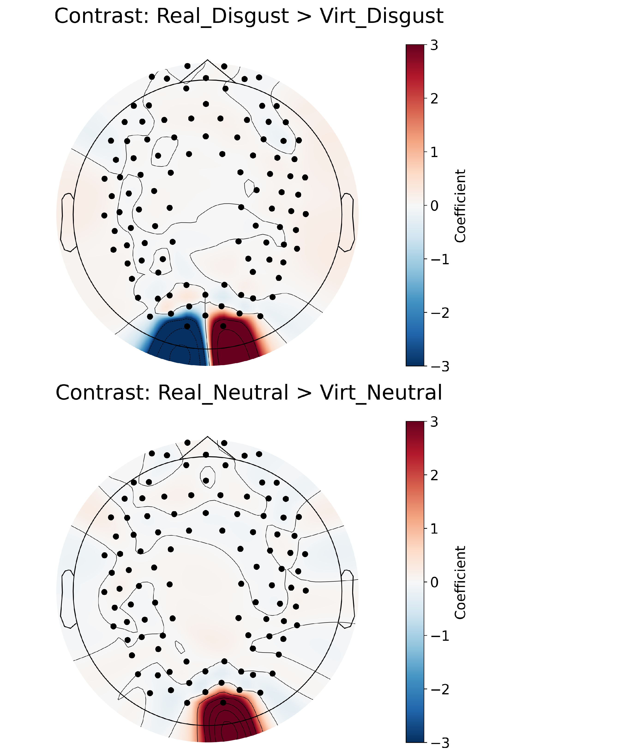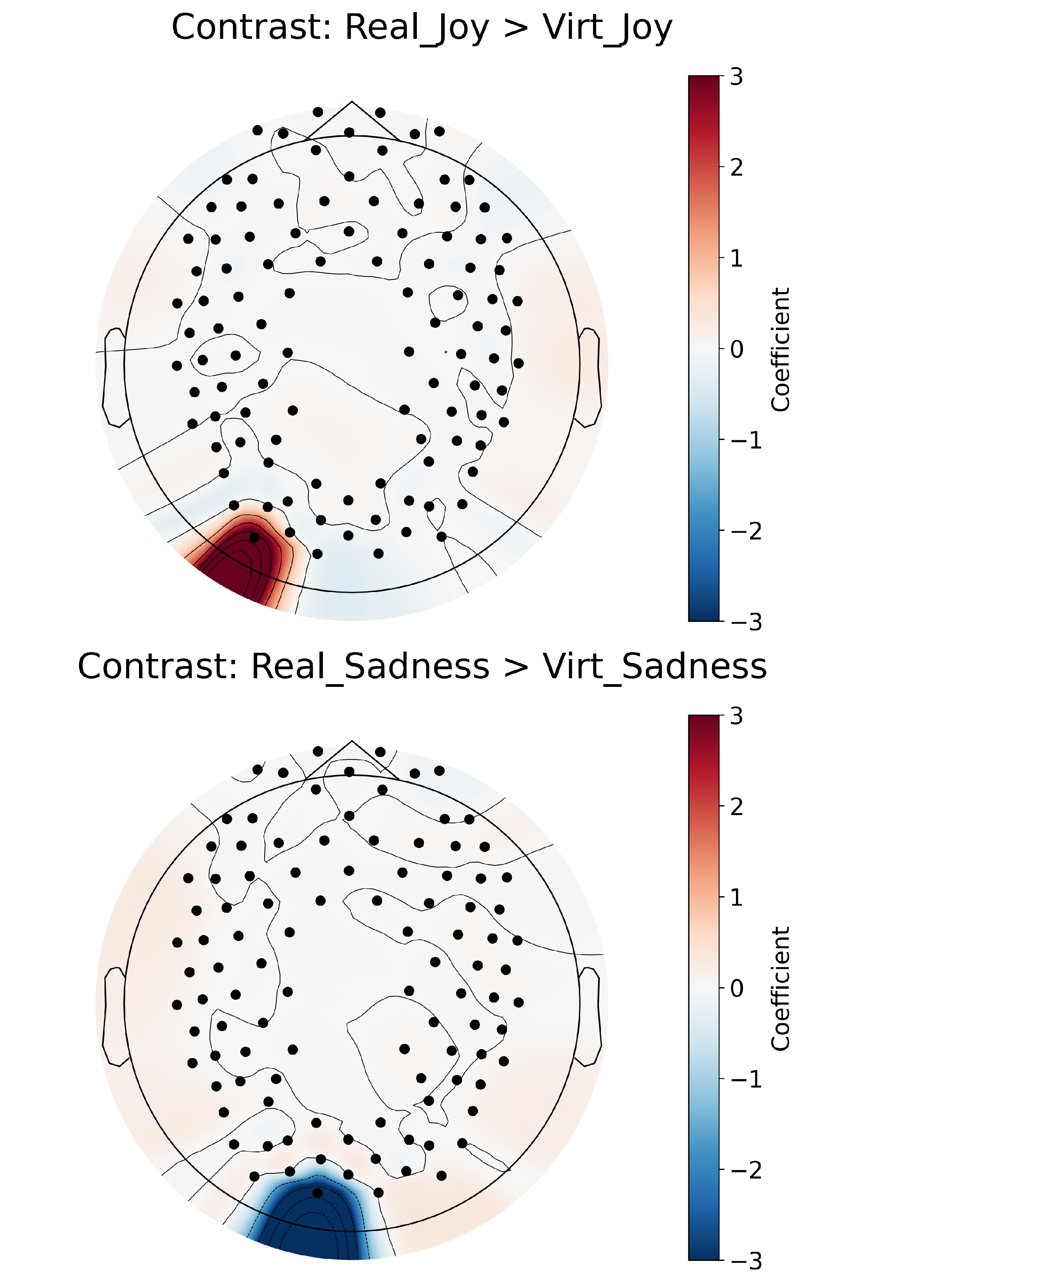

Figure 3.5: GLM results for the contrast between real and virtual conditions within each emotion. Same concept as explained in figure 3.1.

The interaction of face type with emotion (Real *>* Virt within each emotion as shown in 3.5) revealed significant differences in occipital regions exclusively. In the case of disgust, real faces elicited greater activation in the right occipital region compared to virtual faces, while the left occipital region showed the opposite pattern. For Joy and Neutral emotions, real faces also elicited greater activation in the occipital regions compared to virtual faces. For Sadness, the left occipital region showed greater activation for virtual faces compared to real faces. These findings suggest that the neural response to emotional expressions is modulated by the realism of the face stimuli.

The full table of the GLM contrasts for all main effects and interactions can be found in Appendix A.

## Functional Connectivity Results

### Face Type Contrasts

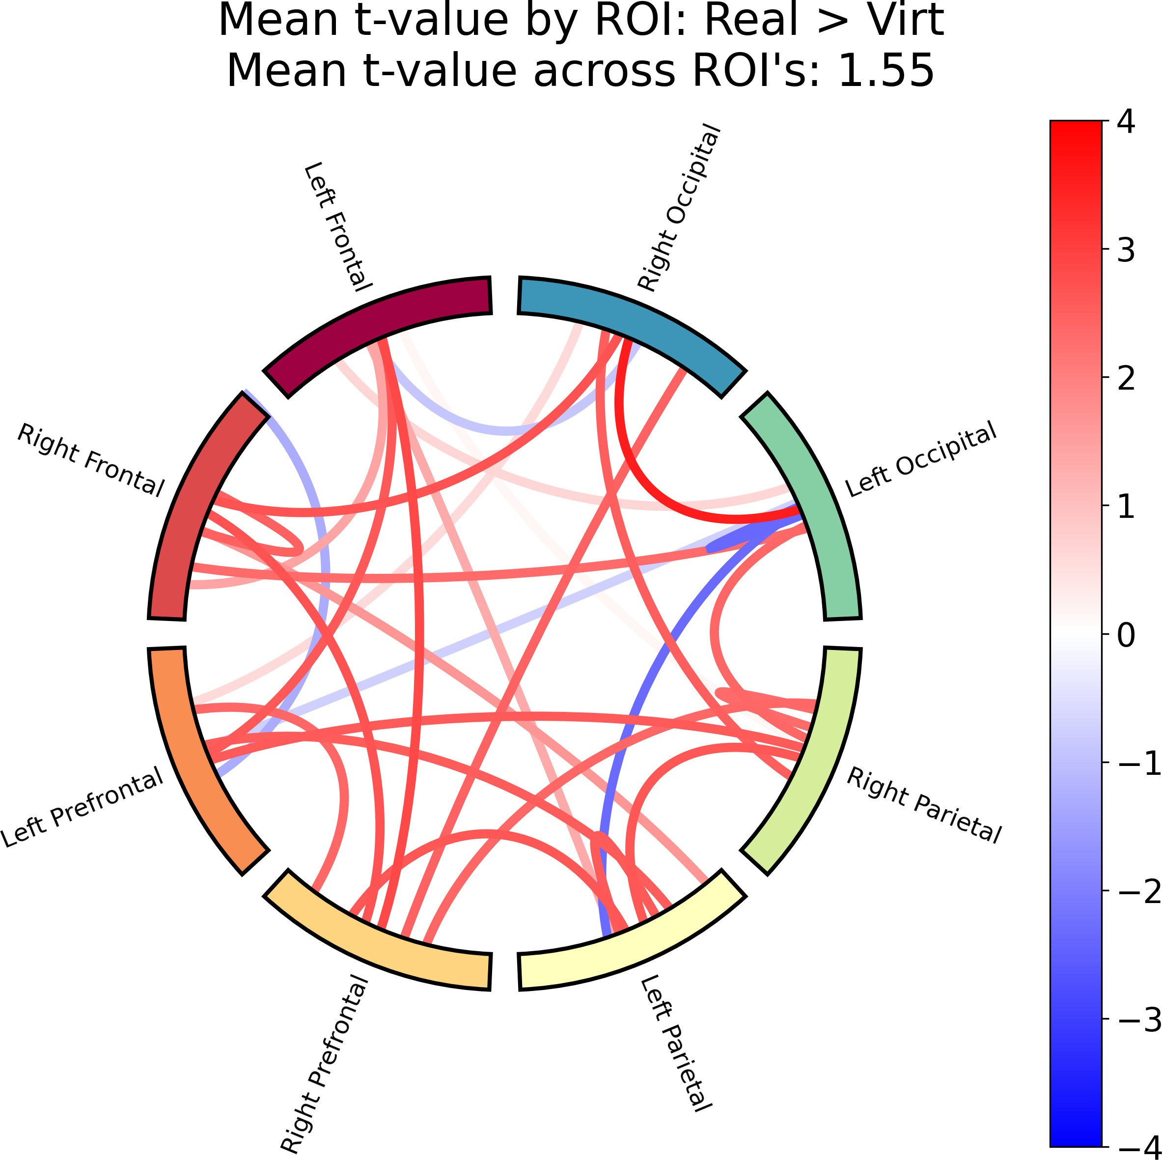

Figure 3.6: Functional connectivity results for the contrast between real and virtual conditions. Red signifies that condition 1 (real faces) has higher connectivity between those two ROI’s than condition 2 (virtual faces), while blue signifies that condition 2 (virtual faces) has higher connectivity than condition 1 (real faces). The color bar on the right shows the *t*-statistic of the contrast, which indicates the strength of the difference in connectivity between the two conditions. The Mean *t*-value across ROI’s is the average of the *t*-values for all significant channel pairs across all ROI’s, and generally indicates whether the connectivity is higher or lower in one condition compared to the other. If this value is positive, it indicates that the connectivity is higher in condition 1 (real faces) than condition 2 (virtual faces), and vice versa.

The main effect of real versus virtual faces (as shown in 3.6) for functional connectivity revealed significant differences in connectivity between real and virtual faces across ROI’s. Most ROI’s showed higher connectivity for real faces compared to virtual faces, with a few exceptions, i.e. the left occipital/parietal ROI, which showed higher connectivity for virtual faces compared to real faces. A mean *t*-value of 1.55 indicates that the connectivity is generally higher for real faces compared to virtual faces across all ROI’s.

### Emotion Contrasts

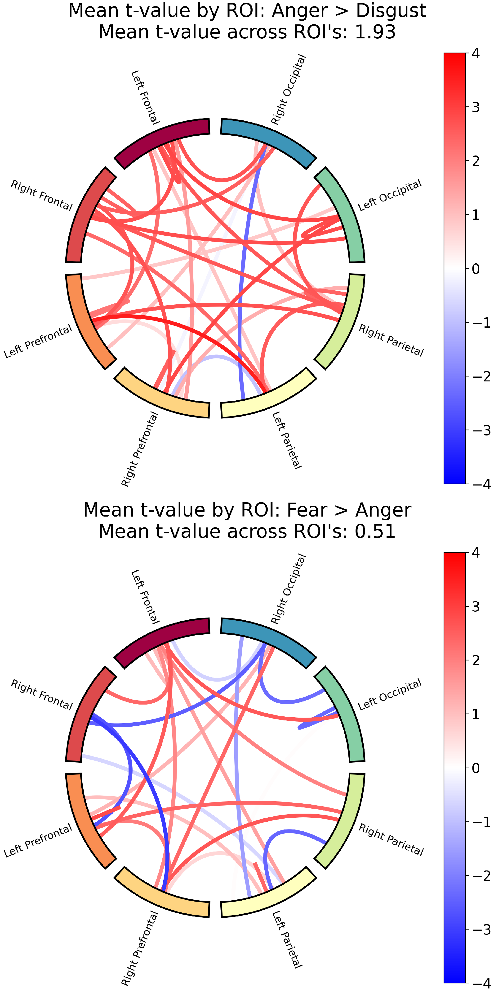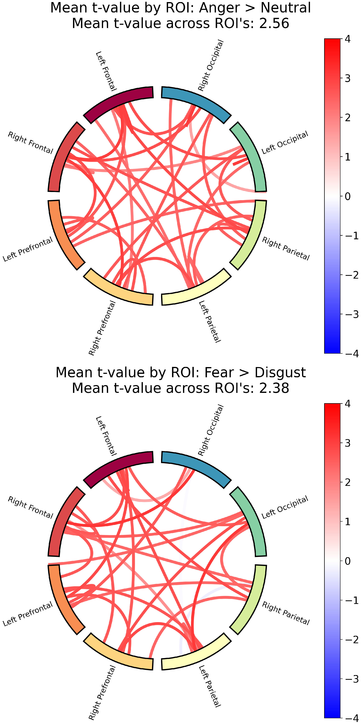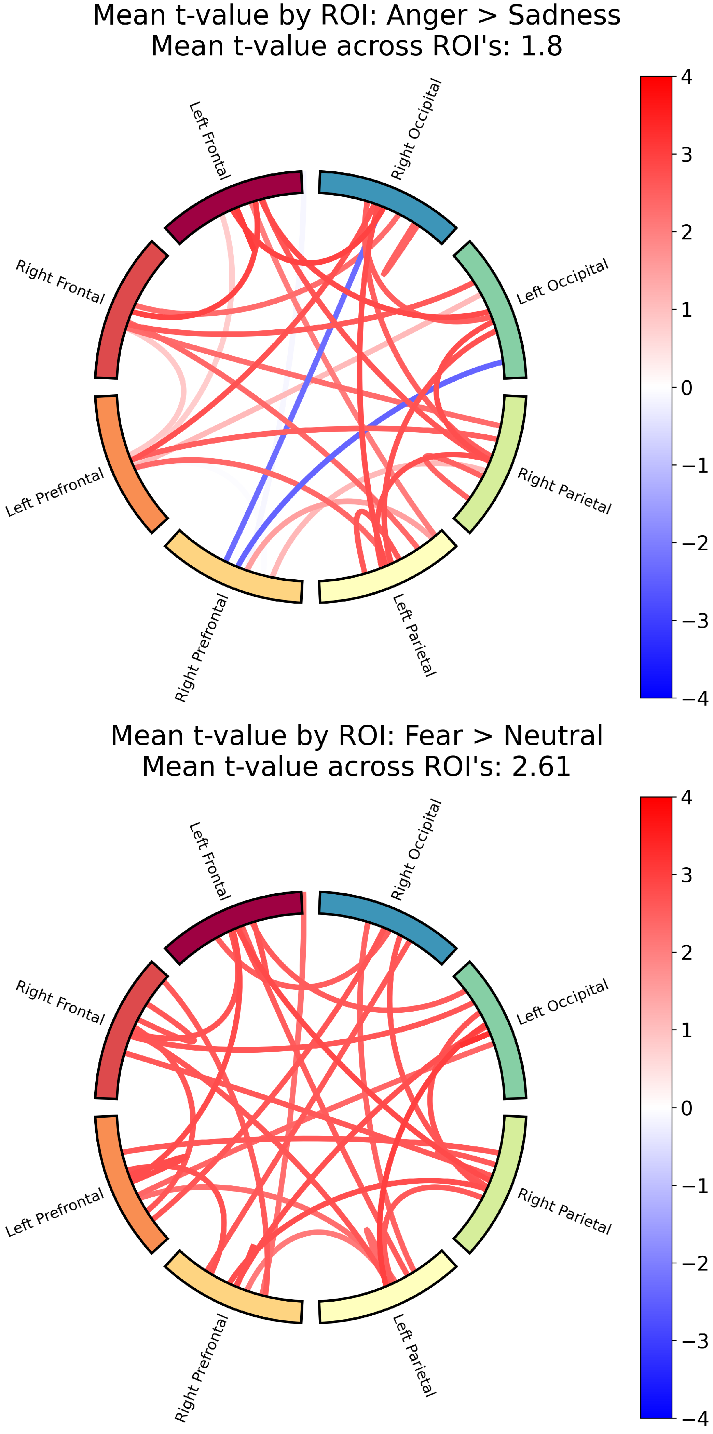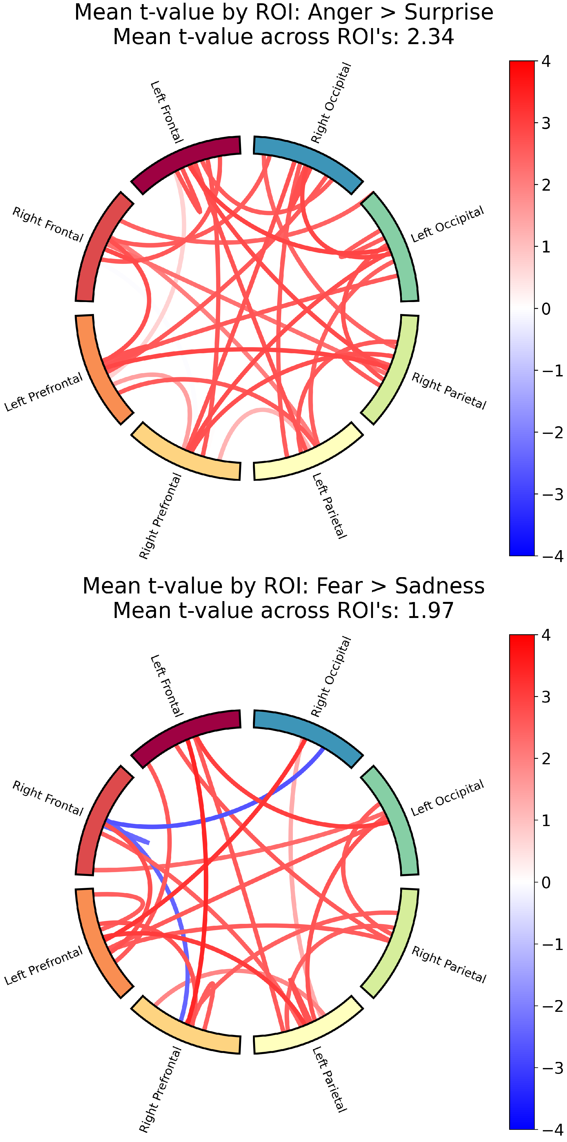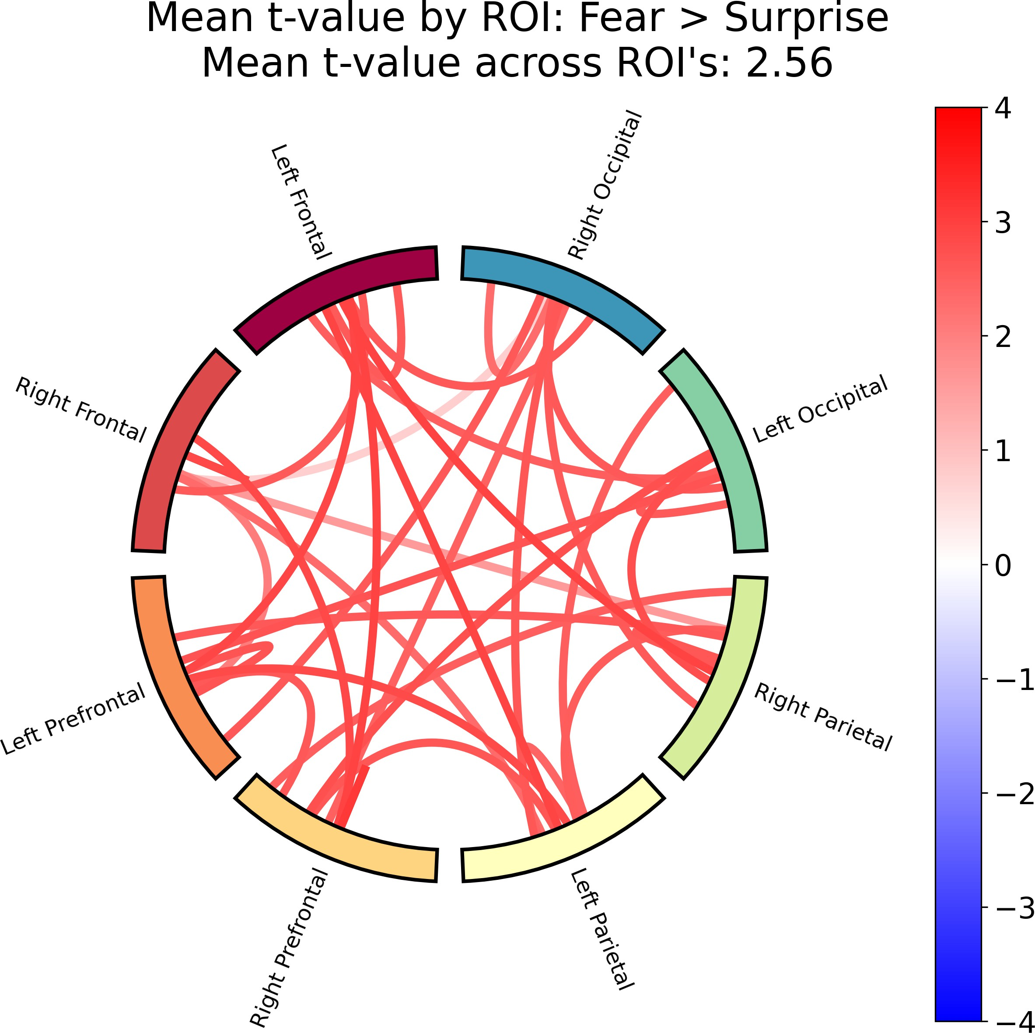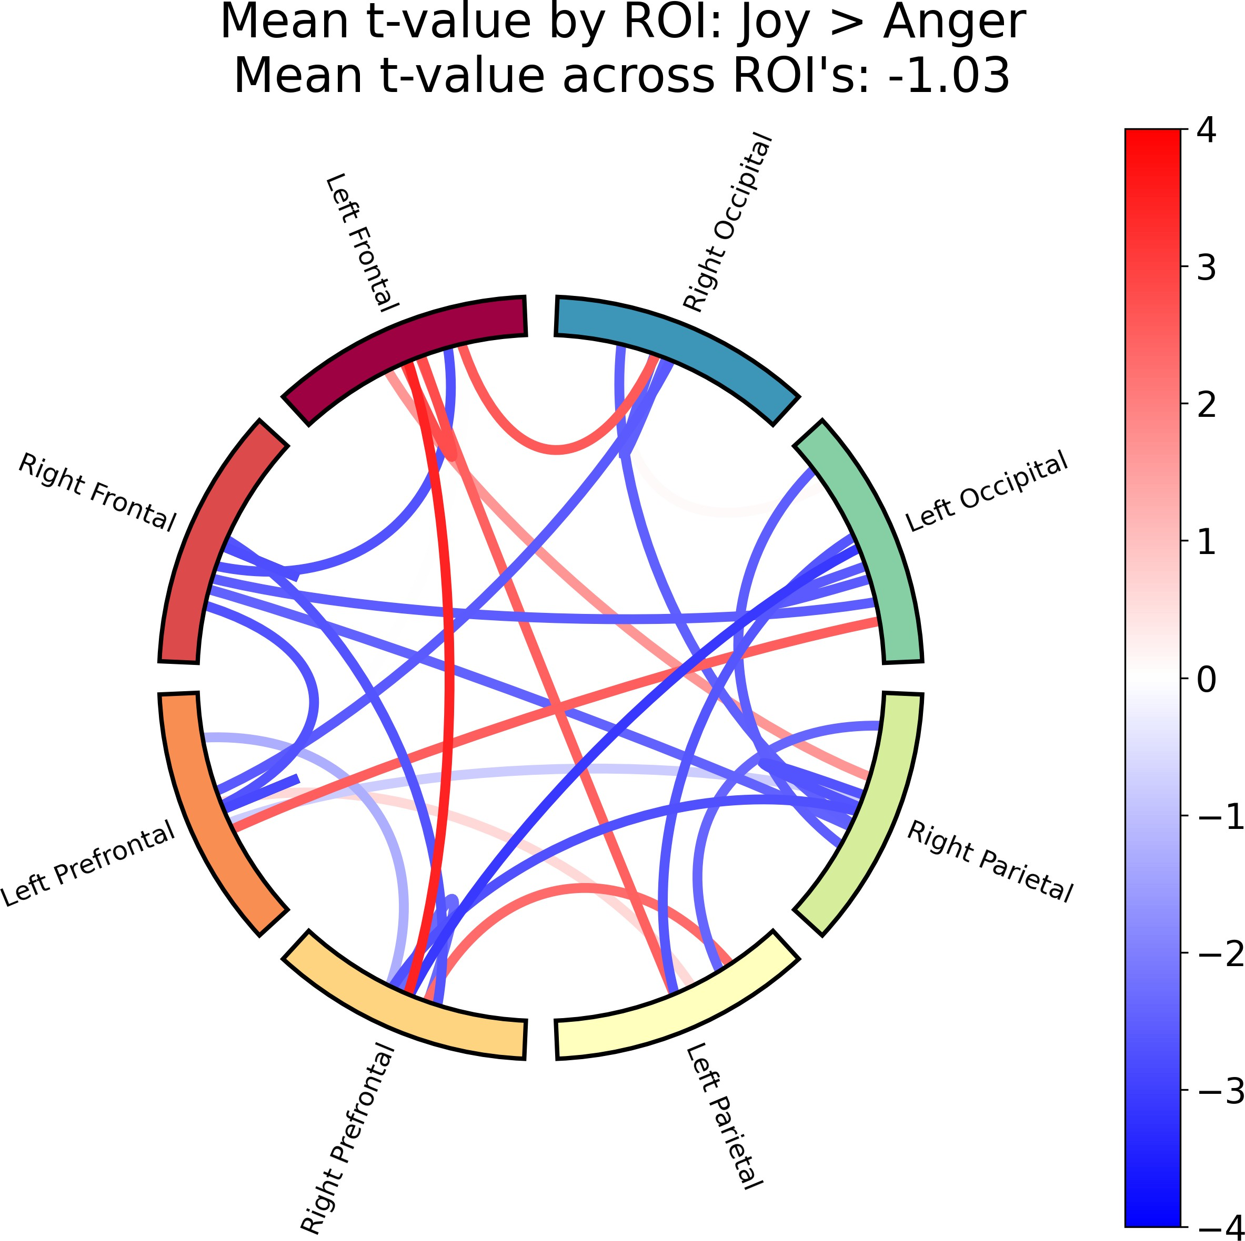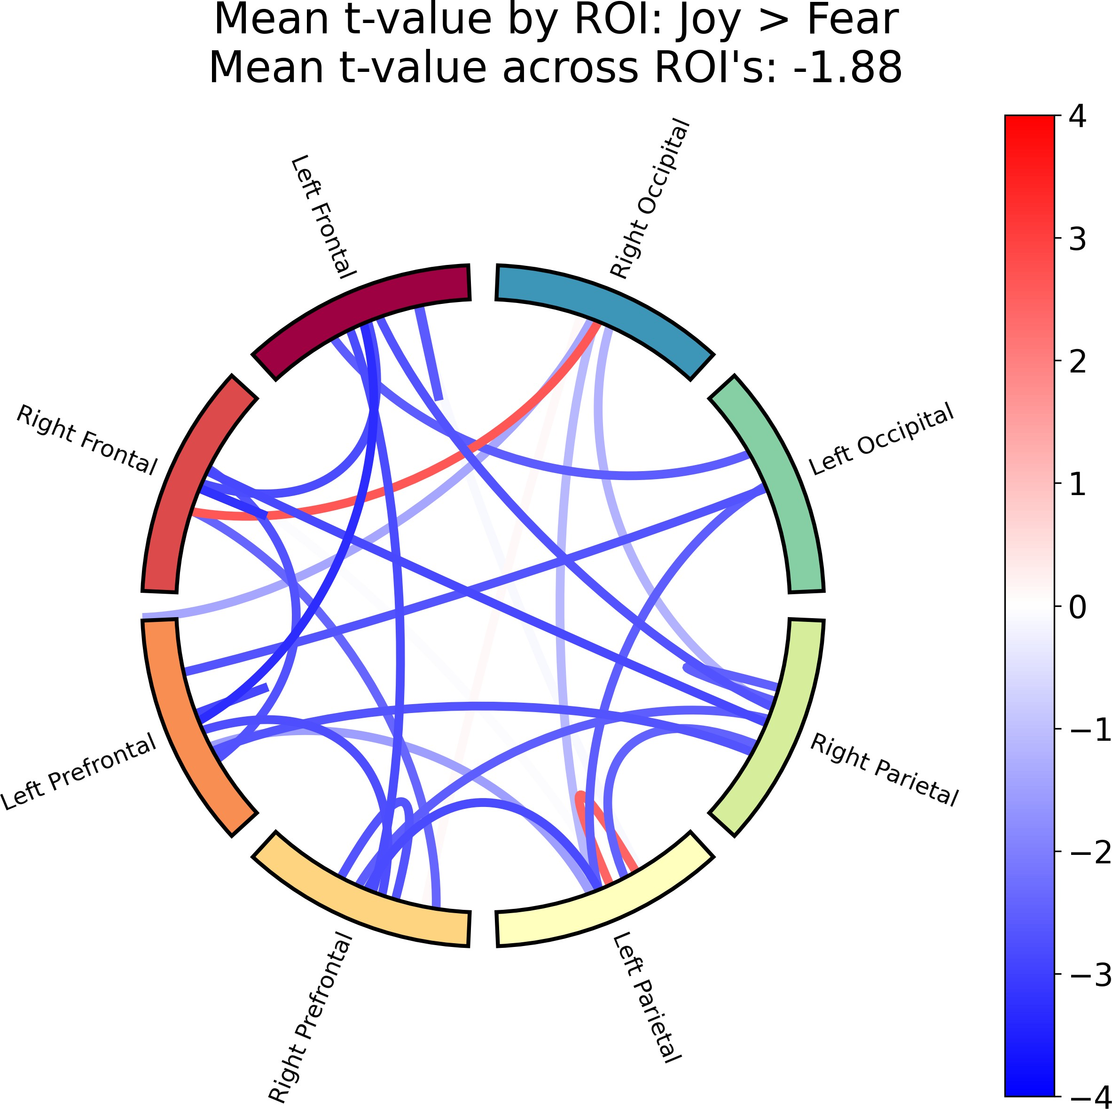

Figure 3.7: Functional connectivity results for Fear and Anger vs. the other emotions. Same concept as explained in figure 3.6.

The emotion contrasts (as shown in 3.7) revealed significant differences in functional connectivity across different emotions and ROI’s. The *t*-values show that Anger and Fear showed higher connectivity in general compared to the other emotions, and when

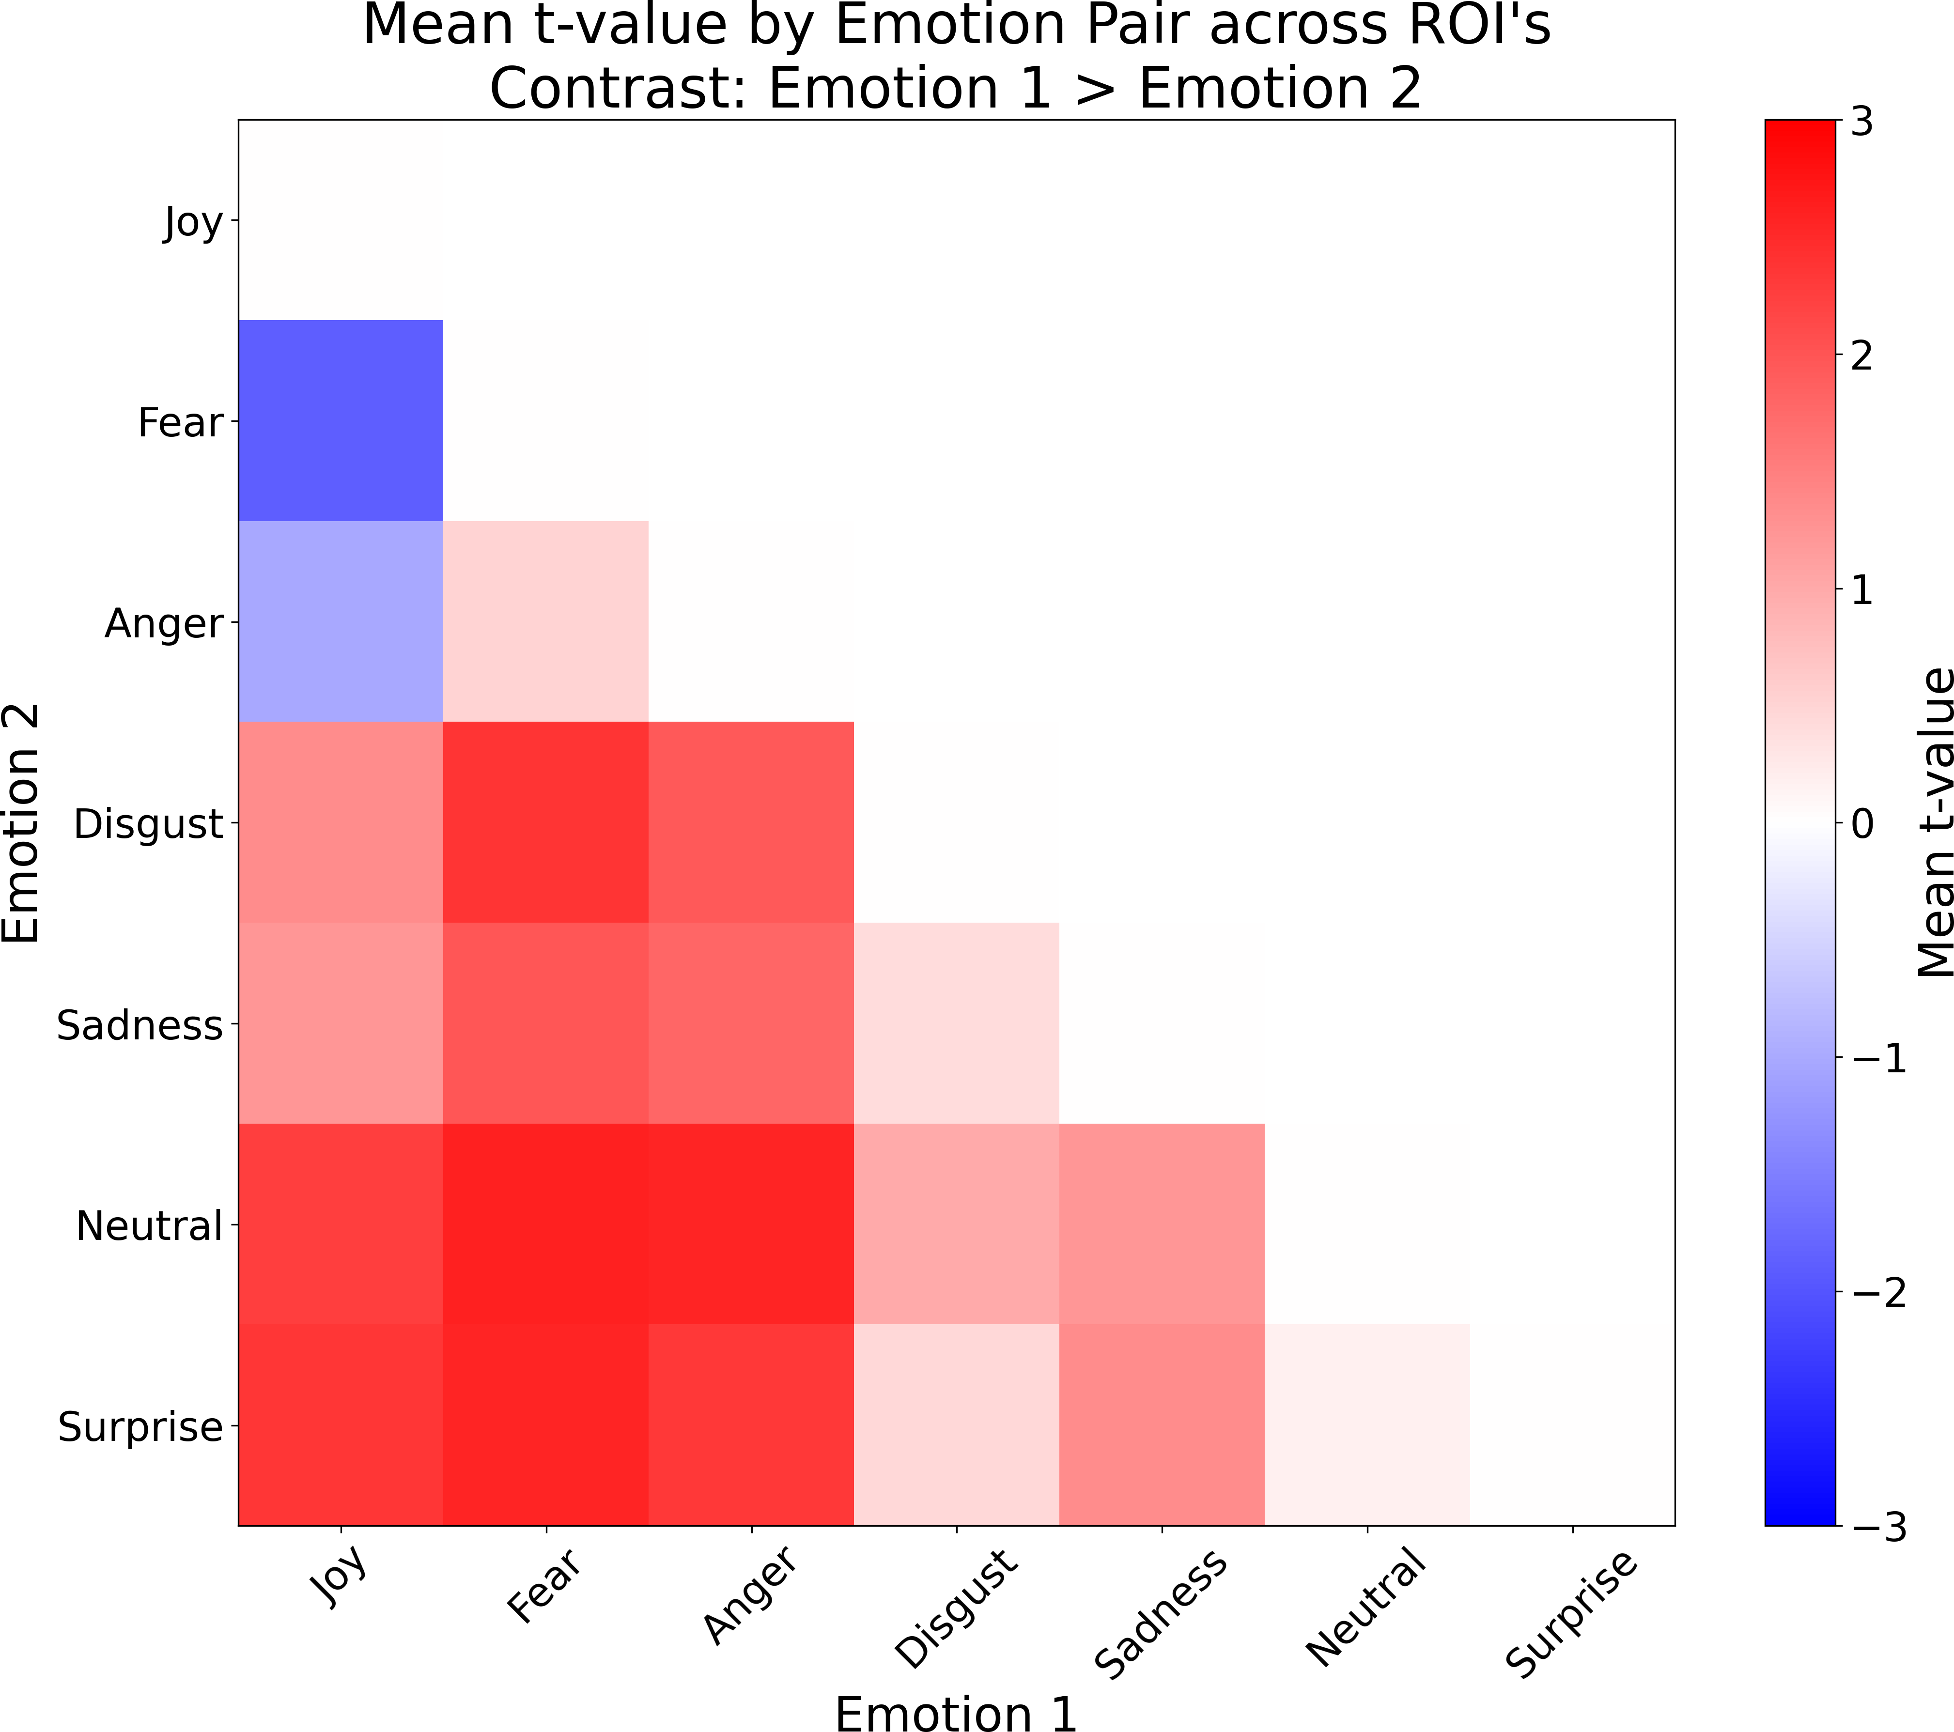compared to each other, Fear has only slightly higher connectivity than Anger. This higher connectivity for Anger and Fear as compared to the other emotions is consistent across most ROI’s as well. The rest of the emotion contrasts can be found in Appendix B, which shows the remaining set of contrasts for all emotions.

Figure 3.8: A heatmap summary of the functional connectivity results for the contrasts between different emotions. Red signifies that emotion 1 has higher connectivity than emotion 2, while blue signifies that emotion 2 has higher connectivity than emotion

1. The color bar on the right shows the *t*-value averaged across all significant channel pairs and across all ROI’s, which indicates the strength of the difference in connectivity between the two emotions. This is the same value that is shown at the top of each plot in figure 3.6 and 3.7.

This summary of the functional connectivity results for the contrasts between different

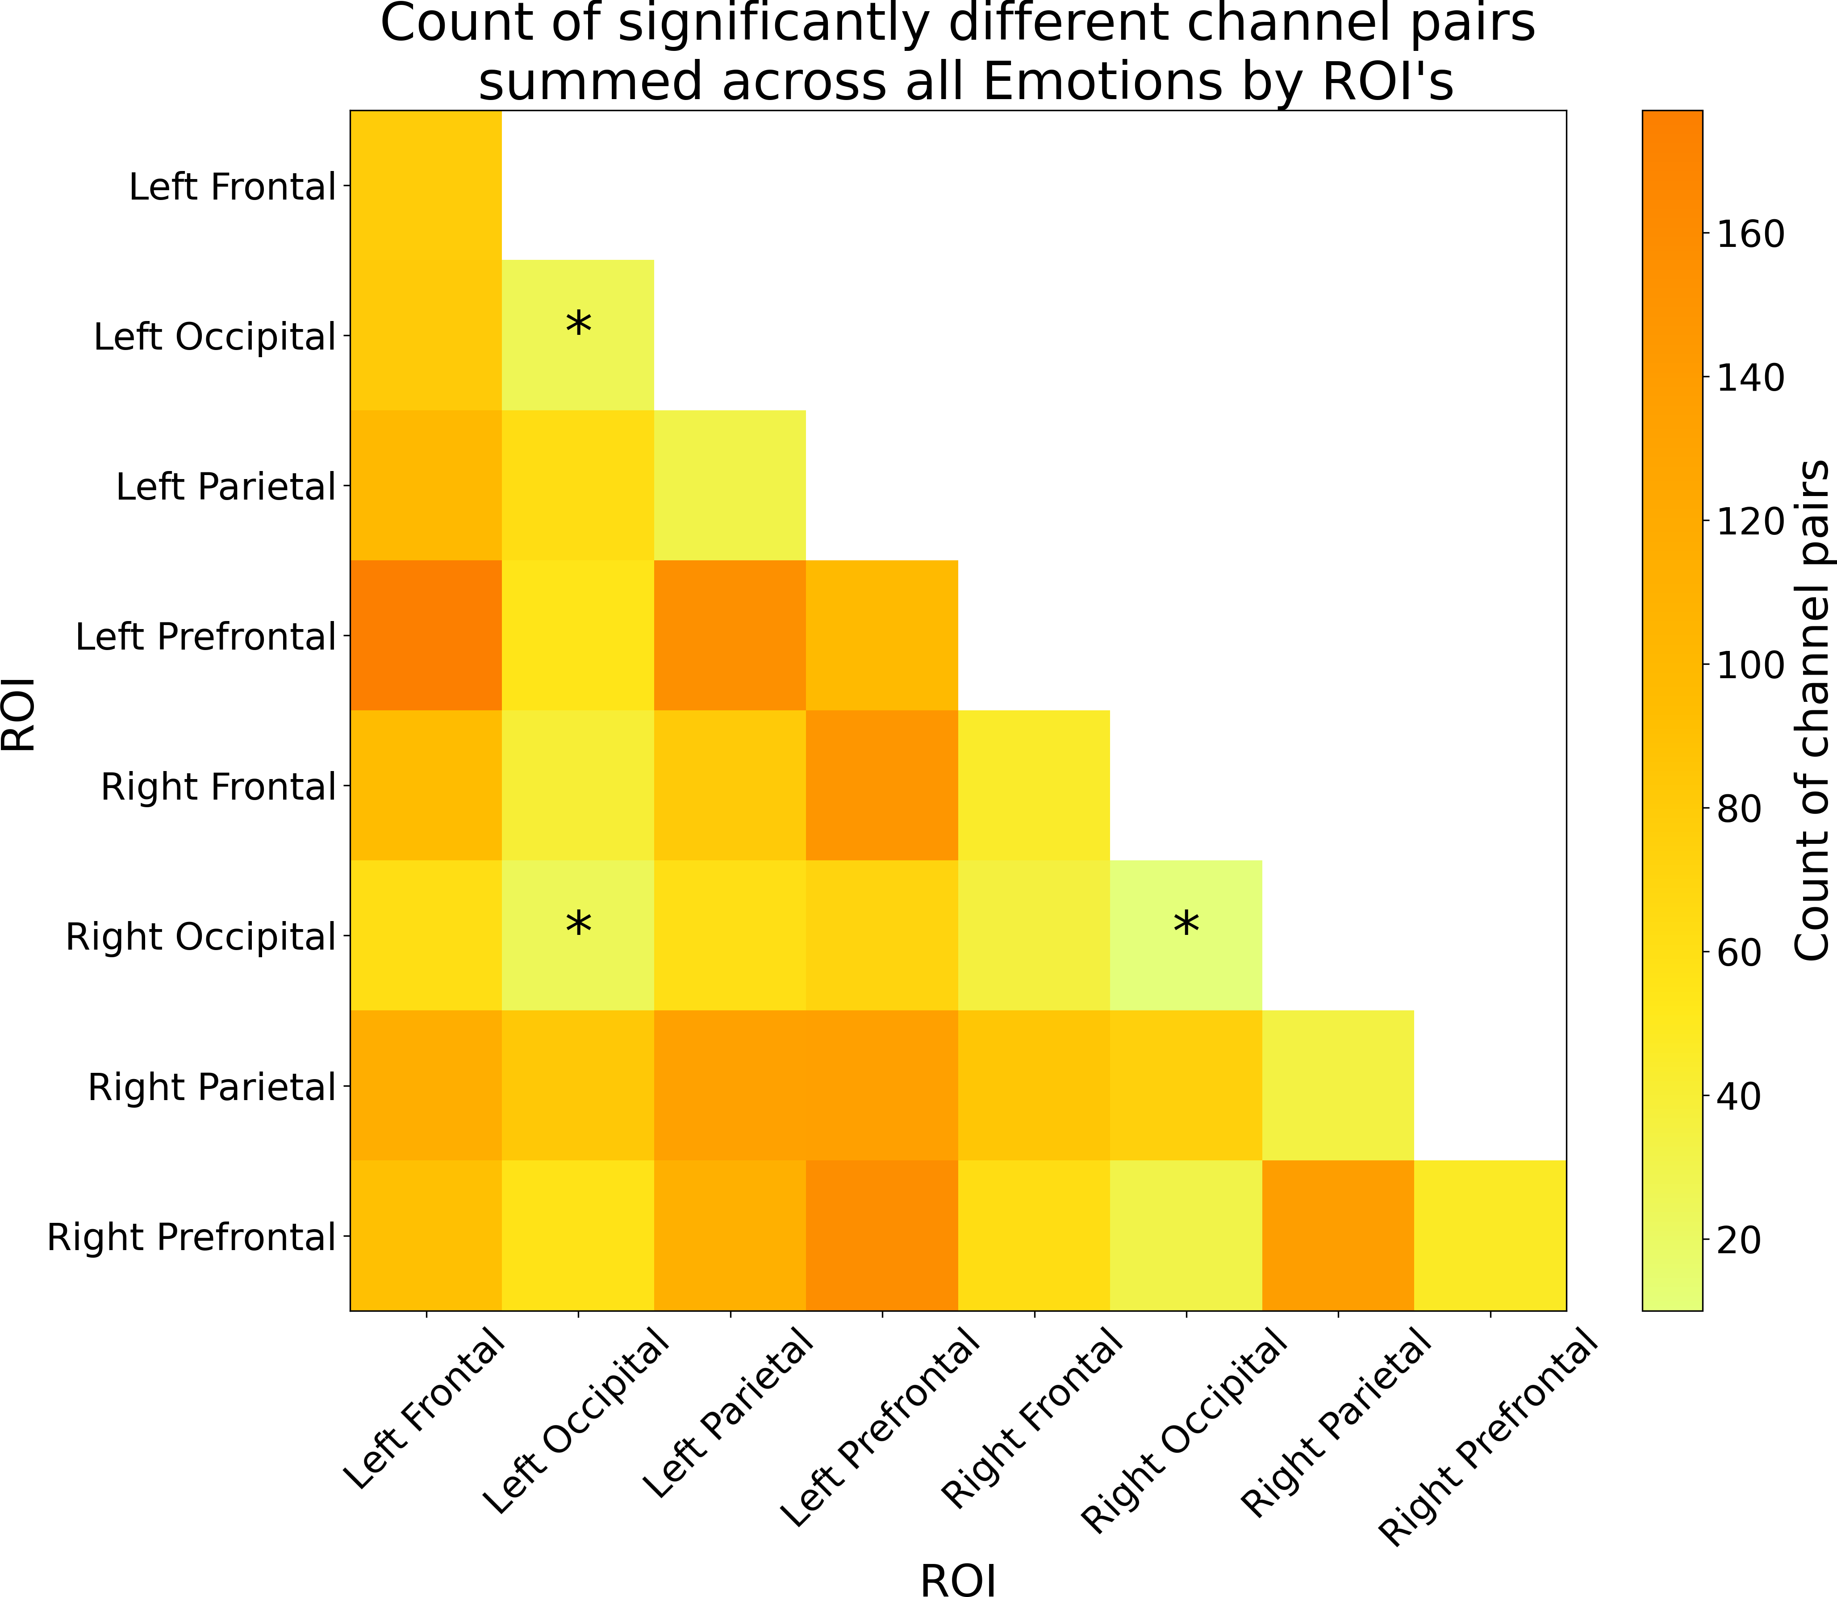emotions (as shown in 3.8) shows that Anger and Fear have the highest connectivity com- pared to the other emotions, with Fear having slightly higher connectivity than Anger. This lines up with figure 3.7, which shows that Anger and Fear have higher connectivity compared to the other emotions.

Figure 3.9: A heatmap summary of the number of significantly different channel pairs for each ROI summed across all emotions. The color bar on the right shows the number of significant channel pairs for each ROI, with brighter colors indicating a smaller number of significant channel pairs, and darker colors indicating a larger number of significant channel pairs. An asterisk was placed on the 3 ROI’s with the least number of significantly different channel pairs to indicate that these ROI’s are more synchronized with each other than any other pair of ROI’s, regardless of the emotion. Note that ROI’s can have differences within them, as each ROI is made up of multiple channels, and the differences are calculated between channels within the same ROI.

The count of significantly different channel pairs for each ROI summed across all emotions (as shown in 3.9) marks 3 regions with an asterisk, these regions have less channel pairs that are significantly different from each other, meaning that these regions are more synchronized with each other than any other pair of ROI’s. These regions are the left occipital/right occipital, left occipital/left occipital, and right occipital/right occipital ROI’s. This indicates that the differences in processing emotions occur in the frontal, prefrontal, and parietal regions of the brain.

### Face Type *×* Emotion Contrasts

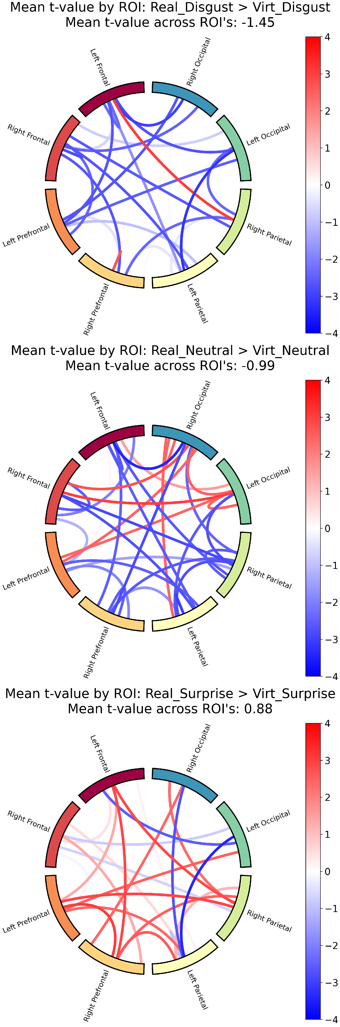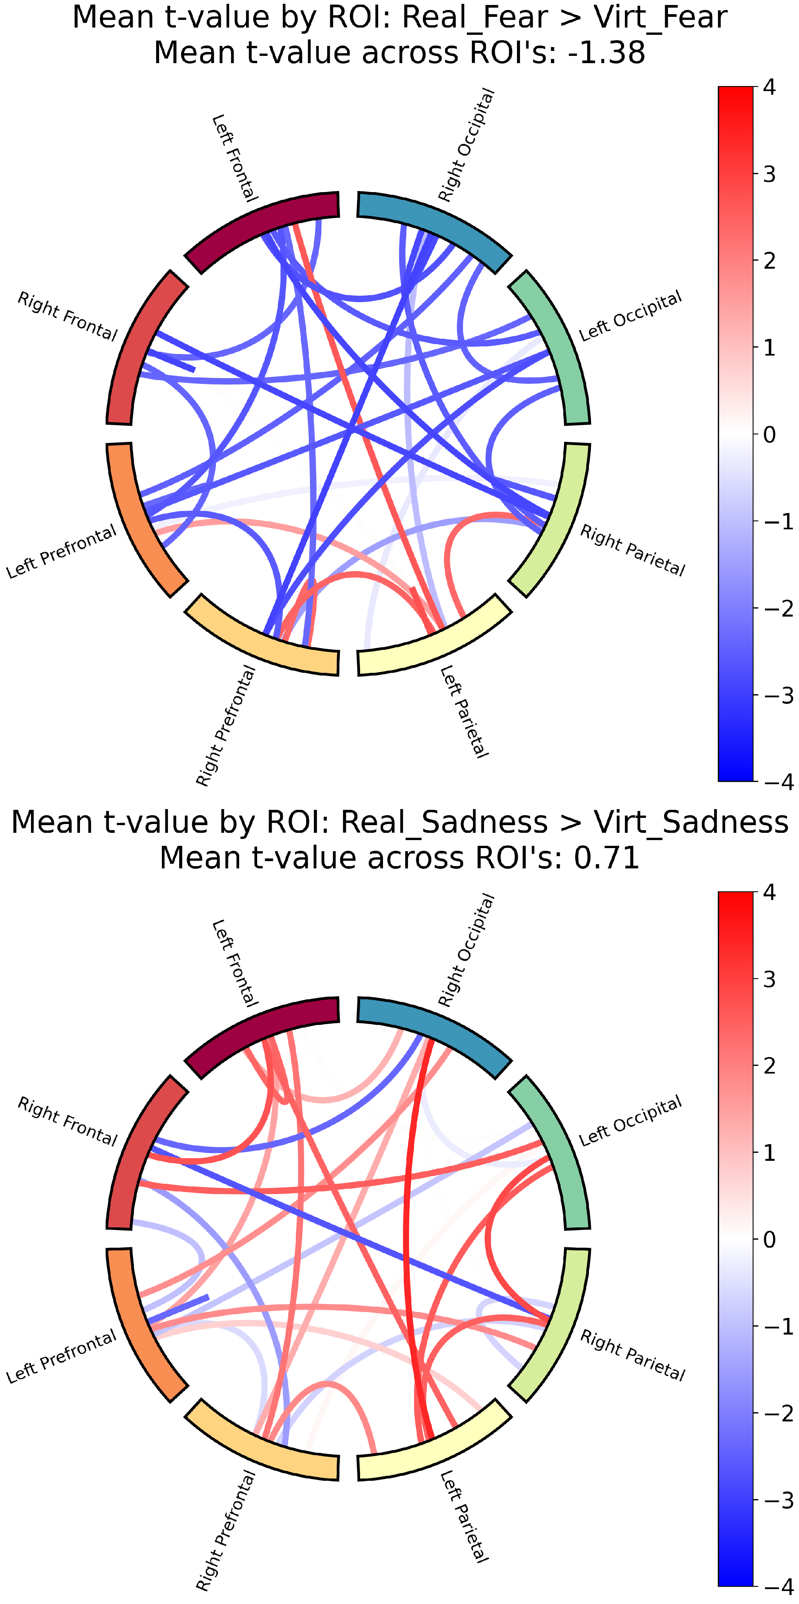

Figure 3.10: Functional connectivity results for the contrast between real and virtual conditions within each emotion. Same concept as explained in figure 3.6.

The interaction of face type with emotion (Real *>* Virt within each emotion as shown in 3.10) revealed significant differences in functional connectivity across both face types within each emotion. For Anger, Disgust, Fear, and Neutral, virtual faces showed higher connectivity across most ROI’s compared to real faces, whereas for Joy, Sadness, and Sur- prise, real faces showed higher connectivity across most ROI’s compared to virtual faces. Like the GLM results, this indicates that the neural response to emotional expressions

is modulated by the realism of the face stimuli, with different patterns of connectivity observed for each face type *×* emotion interaction.

The full table of the functional connectivity contrasts for all main effects and inter- actions can be found in Appendix B.

## Memory Task Results

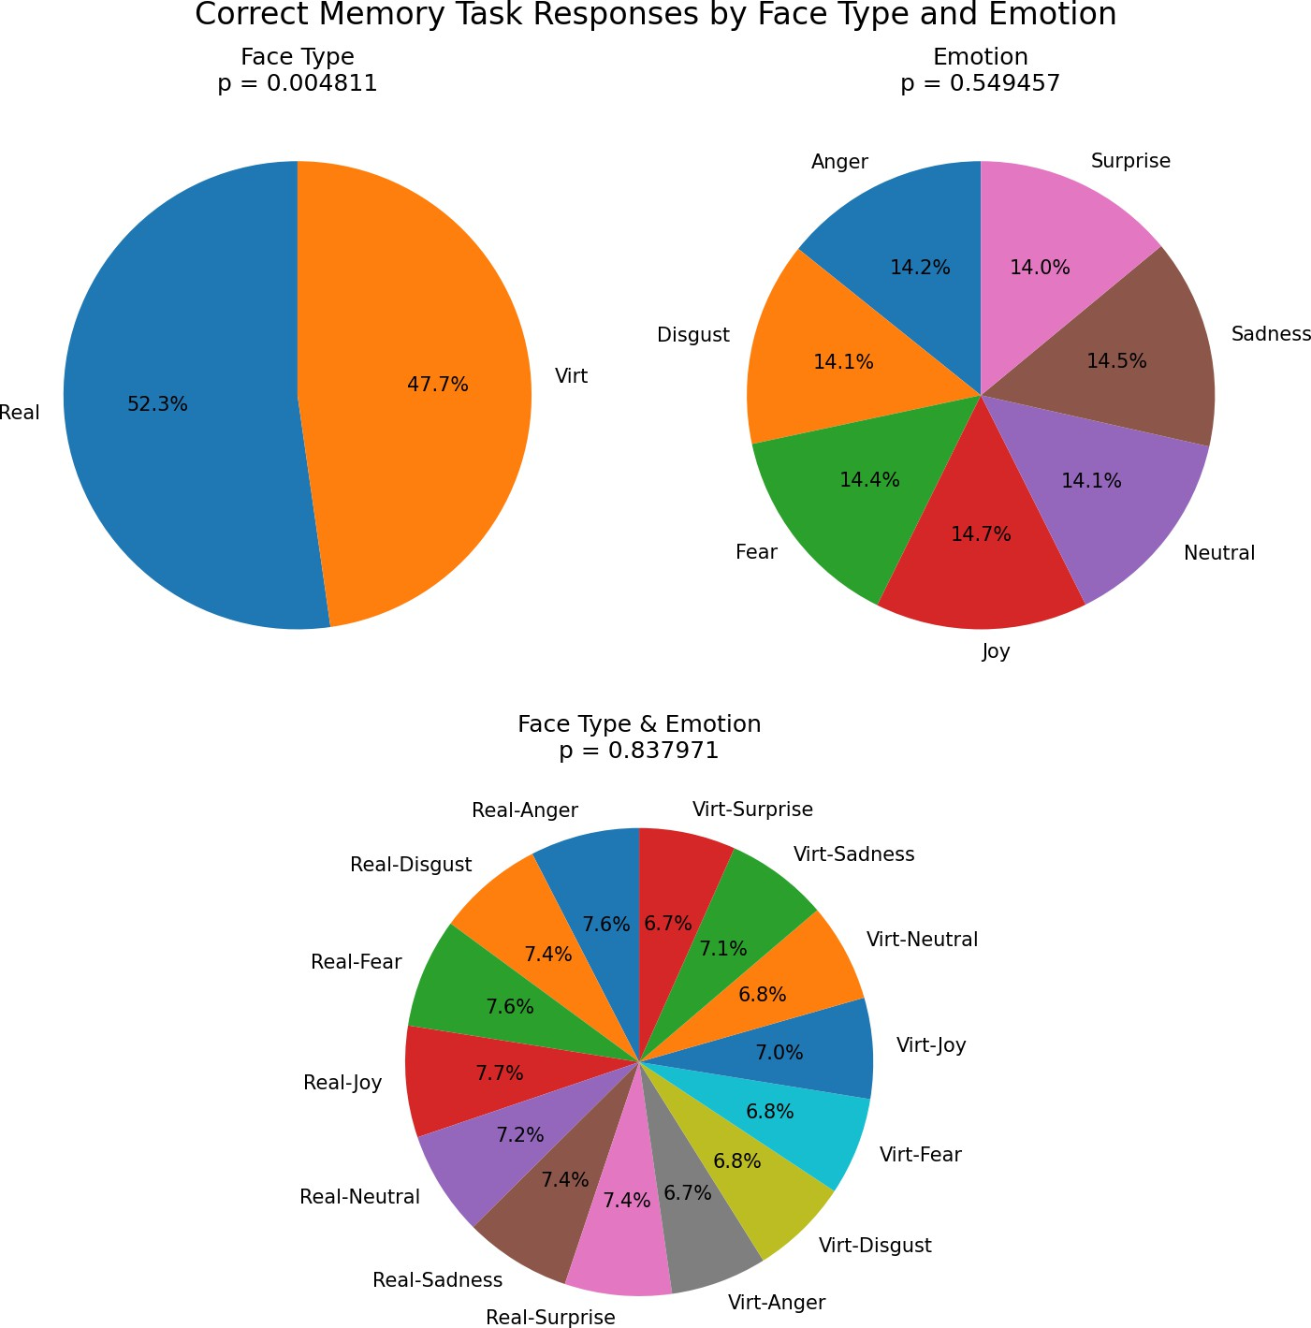

Figure 3.11: Proportion correct by condition in the memory task, plotted separately for real and virtual faces, for each emotion, and the interaction between face type and emotion. The *p*-values indicate the significance of the main effects and interaction.

A two-way Type III ANOVA (as described in 2.5.5) was conducted to examine the main effects and interaction on memory performance (proportion correct). Figure 3.11 shows accuracy by face type/emotion and their interaction. The analysis revealed a significant main effect of face type, *F* (1*,* 4802) = 7*.*96, *p* = 0*.*0048, indicating that memory per- formance was higher for real faces compared to virtual faces. There was no significant main effect of emotion, *F* (6*,* 4802) = 0*.*83, *p* = 0*.*55, nor a significant interaction between face type and emotion, *F* (6*,* 4802) = 0*.*46, *p* = 0*.*84. These findings suggest that while the realism of the face influences memory performance, the specific emotional expression does not have a significant impact on memory accuracy. The full ANOVA table is shown in Appendix C.

# Discussion

## Limitations and Future Directions

* 1. **Conclusion**

Bastos, A. M. and Schoffelen, J.-M. (2016). A Tutorial Review of Functional Con- nectivity Analysis Methods and Their Interpretational Pitfalls. *Frontiers in Systems Neuroscience*, 9. Publisher: Frontiers.

Bergmann, T., Froese, L., Gomez, A., Sainbhi, A. S., Vakitbilir, N., Islam, A., Stein, K., Marquez, I., Amenta, F., Park, K., Ibrahim, Y., and Zeiler, F. A. (2023). Evaluation of Morlet Wavelet Analysis for Artifact Detection in Low-Frequency Commercial Near- Infrared Spectroscopy Systems. *Bioengineering*, 11(1):0.

Bulgarelli, C., Blasi, A., McCann, S., Milosavljevic, B., Ghillia, G., Mbye, E., Touray, E., Fadera, T., Acolatse, L., Moore, S. E., Lloyd-Fox, S., Elwell, C. E., Eggebrecht,

A. T., and Team, t. B. S. (2025). Growth in early infancy drives optimal brain functional connectivity which predicts cognitive flexibility in later childhood. Pages: 2024.01.02.573930 Section: New Results.

Conley, M. I., Dellarco, D. V., Rubien-Thomas, E., Cohen, A. O., Cervera, A., Totten- ham, N., and Casey, B. (2018). The racially diverse affective expression (RADIATE) face stimulus set. *Psychiatry Research*, 270:1059–1067.

Cui, X., Bray, S., and Reiss, A. L. (2010). Functional near infrared spectroscopy (NIRS) signal improvement based on negative correlation between oxygenated and deoxy- genated hemoglobin dynamics. *NeuroImage*, 49(4):3039–3046.

Ekman, P. (1992). Are there basic emotions? *Psychological Review*, 99(3):550–553. Place: US Publisher: American Psychological Association.

Ekman, P. and Friesen, W. V. (1978). Facial action coding system. *Environmental Psychology & Nonverbal Behavior*.

Fishburn, F. A., Ludlum, R. S., Vaidya, C. J., and Medvedev, A. V. (2019). Tempo- ral Derivative Distribution Repair (TDDR): A motion correction method for fNIRS. *NeuroImage*, 184:171–179.

Friston, K. J. (2007). *Statistical parametric mapping: the analysis of functional brain images*. Elsevier / Academic Press, Amsterdam Boston, 1st ed edition.

Gramfort, A., Luessi, M., Larson, E., Engemann, D. A., Strohmeier, D., Brodbeck, C., Goj, R., Jas, M., Brooks, T., Parkkonen, L., and H¨am¨al¨ainen, M. (2013). MEG and EEG data analysis with MNE-Python. *Frontiers in Neuroscience*, 7. Publisher: Frontiers.

Hakim, U., De Felice, S., Pinti, P., Zhang, X., Noah, J., Ono, Y., Burgess, P. W., Hamil- ton, A., Hirsch, J., and Tachtsidis, I. (2023). Quantification of inter-brain coupling: A review of current methods used in haemodynamic and electrophysiological hyperscan- ning studies. *NeuroImage*, 280:120354.

Hernandez, S. M. and Pollonini, L. (2020). NIRSplot: A Tool for Quality Assessment of fNIRS Scans. In *Biophotonics Congress: Biomedical Optics 2020 (Translational, Microscopy, OCT, OTS, BRAIN)*, page BM2C.5, Washington, DC. Optica Publishing Group.

Hocke, L. M., Oni, I. K., Duszynski, C. C., Corrigan, A. V., Frederick, B. D., and Dunn,

J. F. (2018). Automated Processing of fNIRS Data—A Visual Guide to the Pitfalls and Consequences. *Algorithms*, 11(5):67. Number: 5 Publisher: Multidisciplinary Digital Publishing Institute.

Holmes, M., Aalto, D., and Cummine, J. (2024). Opening the dialogue: A preliminary exploration of hair color, hair cleanliness, light, and motion effects on fNIRS signal quality. *PLOS ONE*, 19(5):e0304356. Publisher: Public Library of Science.

Hu, P., Wang, P., Zhao, R., Yang, H., and Biswal, B. B. (2023). Characterizing the spatiotemporal features of functional connectivity across the white matter and gray matter during the naturalistic condition. *Frontiers in Neuroscience*, 17. Publisher: Frontiers.

Kinder, K. T., Heim, H. L. R., Parker, J., Lowery, K., McCraw, A., Eddings, R. N., Defenderfer, J., Sullivan, J., and Buss, A. T. (2022). Systematic review of fNIRS studies reveals inconsistent chromophore data reporting practices. *Neurophotonics*, 9(4):040601.

Kocsis, L., Herman, P., and Eke, A. (2006). The modified Beer–Lambert law revisited.

*Physics in Medicine & Biology*, 51(5):N91.

Lindquist, K. A., Wager, T. D., Kober, H., Bliss-Moreau, E., and Barrett, L. F. (2012). The brain basis of emotion: A meta-analytic review. *Behavioral and Brain Sciences*, 35(3):121–143.

Luke, R., Larson, E. D., Shader, M. J., Innes-Brown, H., Yper, L. V., Lee, A. K. C., Sowman, P. F., and McAlpine, D. (2021). Analysis methods for measuring passive auditory fNIRS responses generated by a block-design paradigm. *Neurophotonics*, 8(2):025008. Publisher: SPIE.

Miranda de S´a, A. M. F. L., Ferreira, D. D., Dias, E. W., Mendes, E. M. A. M., and Felix, L. B. (2009). Coherence estimate between a random and a periodic signal: Bias, variance, analytical critical values, and normalizing transforms. *Journal of the Franklin Institute*, 346(9):841–853.

Oliver, M. M. and Amengual Alcover, E. (2020). UIBVFED: Virtual facial expression dataset. *PLOS ONE*, 15(4):e0231266.

Peirce, J., Gray, J. R., Simpson, S., MacAskill, M., H¨ochenberger, R., Sogo, H., Kastman, E., and Lindeløv, J. K. (2019). PsychoPy2: Experiments in behavior made easy. *Behavior Research Methods*, 51(1):195–203.

Pinti, P., Scholkmann, F., Hamilton, A., Burgess, P., and Tachtsidis, I. (2019). Current Status and Issues Regarding Pre-processing of fNIRS Neuroimaging Data: An Investi- gation of Diverse Signal Filtering Methods Within a General Linear Model Framework. *Frontiers in Human Neuroscience*, 12.

Pollonini, L., Bortfeld, H., and Oghalai, J. S. (2016). PHOEBE: a method for real time mapping of optodes-scalp coupling in functional near-infrared spectroscopy. *Biomedical Optics Express*, 7(12):5104–5119. Publisher: Optica Publishing Group.

Reddy, P., Izzetoglu, M., Shewokis, P. A., Sangobowale, M., Diaz-Arrastia, R., and Izzetoglu, K. (2021). Evaluation of fNIRS signal components elicited by cognitive and hypercapnic stimuli. *Scientific Reports*, 11(1):23457. Publisher: Nature Publishing Group.

Scholkmann, F., Metz, A. J., and Wolf, M. (2014). Measuring tissue hemodynamics and oxygenation by continuous-wave functional near-infrared spectroscopy—how ro- bust are the different calculation methods against movement artifacts? *Physiological Measurement*, 35(4):717. Publisher: IOP Publishing.

Singh, A. K. and Dan, I. (2006). Exploring the false discovery rate in multichannel NIRS.

*NeuroImage*, 33(2):542–549.

Tachtsidis, I. and Scholkmann, F. (2016). False positives and false negatives in functional near-infrared spectroscopy: issues, challenges, and the way forward. *Neurophotonics*, 3(3):031405. Publisher: SPIE.

Xu, G., Zhang, M., Wang, Y., Liu, Z., Huo, C., Li, Z., and Huo, M. (2017). Functional connectivity analysis of distracted drivers based on the wavelet phase coherence of functional near-infrared spectroscopy signals. *PLOS ONE*, 12(11):e0188329. Publisher: Public Library of Science.

# Appendix A GLM Contrasts

Table A.1: Table of contrast results from the GLM analysis.

|  |  |  |  |  |  |  |
| --- | --- | --- | --- | --- | --- | --- |
| Contrast | Region | Ch Name | Coef. | Std.Err. | *z* | *pfdr* |

|  |  |  |  |  |  |  |
| --- | --- | --- | --- | --- | --- | --- |
| Real *>* Virt | Left Occipital | S23 D15 hbt | -1.550 | 0.394 | -3.937 | 0.009 |
| Joy *>* Neutral | Right Parietal | S20 D29 hbt | 2.611 | 0.623 | 4.194 | 0.001 |
| Joy *>* Neutral | Right Occipital | S23 D30 hbt | -3.144 | 0.623 | -5.050 | 0.000 |
| Joy *>* Surprise | Right Occipital | S23 D16 hbt | -2.884 | 0.647 | -4.460 | 0.001 |
| Joy *>* Surprise | Left Prefrontal | S25 D6 hbt | -2.379 | 0.647 | -3.679 | 0.012 |
| Fear *>* Neutral | Right Occipital | S23 D30 hbt | -2.126 | 0.557 | -3.819 | 0.014 |
| Fear *>* Surprise | Right Parietal | S20 D29 hbt | -2.048 | 0.568 | -3.606 | 0.032 |
| Anger *>* Neutral | Right Occipital | S23 D30 hbt | -3.620 | 0.652 | -5.547 | 0.000 |
| Disgust *>* Surprise | Right Occipital | S23 D16 hbt | -2.507 | 0.640 | -3.920 | 0.005 |
| Disgust *>* Surprise | Left Prefrontal | S25 D6 hbt | -2.531 | 0.640 | -3.958 | 0.005 |
| Sadness *>* Neutral | Left Frontal | S4 D6 hbt | -2.257 | 0.601 | -3.754 | 0.018 |
| Sadness *>* Surprise | Left Frontal | S4 D6 hbt | -2.610 | 0.673 | -3.879 | 0.011 |
| Sadness *>* Surprise | Right Parietal | S20 D29 hbt | -2.304 | 0.673 | -3.425 | 0.032 |

Continued on next page

37

|  |  |  |  |  |  |  |
| --- | --- | --- | --- | --- | --- | --- |
| Contrast | Region | Ch Name | Coef. | Std.Err. | *z* | *pfdr* |

|  |  |  |  |  |  |  |
| --- | --- | --- | --- | --- | --- | --- |
| Neutral *>* Surprise | Right Parietal | S20 D29 hbt | -2.653 | 0.625 | -4.247 | 0.002 |
| Neutral *>* Surprise | Right Occipital | S23 D30 hbt | 2.461 | 0.625 | 3.940 | 0.004 |
| Real Joy *>* Real Disgust | Right Occipital | S23 D30 hbt | -5.344 | 1.093 | -4.889 | 0.000 |
| Real Joy *>* Real Sadness | Right Occipital | S24 D30 hbt | -3.816 | 0.964 | -3.958 | 0.008 |
| Real Joy *>* Real Neutral | Right Occipital | S23 D30 hbt | -5.786 | 0.980 | -5.906 | 0.000 |
| Real Joy *>* Real Surprise | Right Frontal | S9 D19 hbt | 3.093 | 0.997 | 3.101 | 0.050 |
| Real Joy *>* Real Surprise | Left Occipital | S23 D15 hbt | -3.754 | 0.997 | -3.764 | 0.017 |
| Real Joy *>* Real Surprise | Right Occipital | S23 D16 hbt | -3.577 | 0.997 | -3.587 | 0.017 |
| Real Joy *>* Real Surprise | Left Prefrontal | S25 D6 hbt | -3.293 | 0.997 | -3.302 | 0.033 |
| Real Joy *>* Virt Joy | Left Occipital | S32 D15 hbt | 3.484 | 0.966 | 3.607 | 0.032 |
| Real Joy *>* Virt Fear | Left Occipital | S23 D15 hbt | -3.384 | 0.965 | -3.506 | 0.023 |
| Real Joy *>* Virt Fear | Right Occipital | S23 D30 hbt | -3.649 | 0.965 | -3.781 | 0.016 |
| Real Joy *>* Virt Disgust | Left Occipital | S23 D15 hbt | -4.428 | 0.986 | -4.490 | 0.001 |
| Real Joy *>* Virt Sadness | Left Occipital | S23 D15 hbt | -4.435 | 0.973 | -4.556 | 0.001 |
| Real Joy *>* Virt Surprise | Right Occipital | S23 D16 hbt | -3.197 | 0.949 | -3.368 | 0.039 |
| Real Joy *>* Virt Surprise | Right Occipital | S23 D30 hbt | -3.410 | 0.949 | -3.593 | 0.034 |
| Real Fear *>* Real Disgust | Right Occipital | S23 D30 hbt | -4.918 | 1.087 | -4.522 | 0.001 |
| Real Fear *>* Real Neutral | Right Occipital | S23 D30 hbt | -5.360 | 0.980 | -5.470 | 0.000 |
| Real Fear *>* Virt Joy | Left Prefrontal | S25 D6 hbt | 4.150 | 1.054 | 3.938 | 0.008 |
| Real Fear *>* Virt Disgust | Left Occipital | S23 D15 hbt | -4.112 | 1.009 | -4.073 | 0.002 |
| Real Fear *>* Virt Disgust | Left Prefrontal | S25 D6 hbt | 4.183 | 1.009 | 4.144 | 0.002 |
| Real Fear *>* Virt Sadness | Left Occipital | S23 D15 hbt | -4.119 | 1.003 | -4.109 | 0.004 |
| Real Fear *>* Virt Sadness | Left Prefrontal | S25 D6 hbt | 3.595 | 1.003 | 3.585 | 0.017 |

|  |  |  |  |  |  |  |
| --- | --- | --- | --- | --- | --- | --- |
| Contrast | Region | Ch Name | Coef. | Std.Err. | *z* | *pfdr* |

|  |  |  |  |  |  |  |
| --- | --- | --- | --- | --- | --- | --- |
| Real Anger *>* Real Disgust | Right Occipital | S23 D30 hbt | -4.697 | 1.117 | -4.205 | 0.003 |
| Real Anger *>* Real Neutral | Right Occipital | S23 D30 hbt | -5.139 | 0.983 | -5.226 | 0.000 |
| Real Disgust *>* Real Surprise | Left Frontal | S4 D6 hbt | -3.742 | 1.107 | -3.380 | 0.025 |
| Real Disgust *>* Real Surprise | Left Occipital | S23 D15 hbt | -4.679 | 1.107 | -4.226 | 0.002 |
| Real Disgust *>* Real Surprise | Right Occipital | S23 D30 hbt | 4.221 | 1.107 | 3.813 | 0.007 |
| Real Disgust *>* Virt Fear | Left Occipital | S23 D15 hbt | -4.309 | 1.013 | -4.252 | 0.002 |
| Real Disgust *>* Virt Disgust | Left Occipital | S23 D15 hbt | -5.353 | 1.163 | -4.603 | 0.000 |
| Real Disgust *>* Virt Disgust | Right Occipital | S23 D30 hbt | 5.028 | 1.163 | 4.323 | 0.001 |
| Real Disgust *>* Virt Sadness | Left Occipital | S23 D15 hbt | -5.360 | 1.163 | -4.608 | 0.000 |
| Real Disgust *>* Virt Sadness | Right Occipital | S23 D30 hbt | 4.254 | 1.163 | 3.657 | 0.013 |
| Real Disgust *>* Virt Neutral | Right Occipital | S23 D30 hbt | 3.878 | 1.102 | 3.520 | 0.044 |
| Real Sadness *>* Real Neutral | Right Occipital | S23 D30 hbt | -3.749 | 0.912 | -4.110 | 0.002 |
| Real Sadness *>* Real Neutral | Right Occipital | S24 D30 hbt | 4.012 | 0.912 | 4.398 | 0.001 |
| Real Sadness *>* Real Surprise | Left Frontal | S4 D6 hbt | -3.743 | 1.059 | -3.534 | 0.021 |
| Real Sadness *>* Real Surprise | Right Occipital | S24 D30 hbt | 4.688 | 1.059 | 4.426 | 0.001 |
| Real Sadness *>* Virt Joy | Right Occipital | S24 D30 hbt | 3.811 | 1.048 | 3.638 | 0.028 |
| Real Sadness *>* Virt Disgust | Left Occipital | S23 D15 hbt | -3.951 | 1.088 | -3.633 | 0.029 |
| Real Sadness *>* Virt Sadness | Left Occipital | S23 D15 hbt | -3.959 | 1.051 | -3.766 | 0.017 |
| Real Neutral *>* Real Surprise | Right Parietal | S20 D29 hbt | -3.553 | 0.933 | -3.809 | 0.007 |
| Real Neutral *>* Real Surprise | Right Occipital | S23 D30 hbt | 4.663 | 0.933 | 4.999 | 0.000 |
| Real Neutral *>* Virt Joy | Right Occipital | S23 D30 hbt | 3.563 | 0.924 | 3.856 | 0.012 |
| Real Neutral *>* Virt Anger | Left Frontal | S4 D6 hbt | 4.371 | 1.009 | 4.330 | 0.002 |
| Real Neutral *>* Virt Anger | Right Occipital | S23 D30 hbt | 3.737 | 1.009 | 3.702 | 0.011 |

|  |  |  |  |  |  |  |
| --- | --- | --- | --- | --- | --- | --- |
| Contrast | Region | Ch Name | Coef. | Std.Err. | *z* | *pfdr* |

|  |  |  |  |  |  |  |
| --- | --- | --- | --- | --- | --- | --- |
| Real Neutral *>* Virt Disgust | Right Occipital | S23 D30 hbt | 5.470 | 1.020 | 5.365 | 0.000 |
| Real Neutral *>* Virt Sadness | Left Frontal | S4 D6 hbt | 4.863 | 0.963 | 5.051 | 0.000 |
| Real Neutral *>* Virt Sadness | Right Occipital | S23 D30 hbt | 4.696 | 0.963 | 4.877 | 0.000 |
| Real Neutral *>* Virt Neutral | Right Occipital | S23 D30 hbt | 4.320 | 0.994 | 4.346 | 0.001 |
| Real Surprise *>* Virt Joy | Left Frontal | S4 D6 hbt | 3.580 | 1.038 | 3.448 | 0.029 |
| Real Surprise *>* Virt Joy | Left Prefrontal | S25 D6 hbt | 4.185 | 1.038 | 4.030 | 0.006 |
| Real Surprise *>* Virt Anger | Left Frontal | S4 D6 hbt | 5.443 | 1.096 | 4.966 | 0.000 |
| Real Surprise *>* Virt Anger | Right Frontal | S10 D17 hbt | -3.659 | 1.096 | -3.338 | 0.029 |
| Real Surprise *>* Virt Anger | Left Occipital | S23 D15 hbt | 3.907 | 1.096 | 3.565 | 0.019 |
| Real Surprise *>* Virt Disgust | Left Prefrontal | S25 D6 hbt | 4.218 | 1.042 | 4.048 | 0.005 |
| Real Surprise *>* Virt Sadness | Left Frontal | S4 D6 hbt | 5.935 | 1.000 | 5.937 | 0.000 |
| Real Surprise *>* Virt Sadness | Left Prefrontal | S7 D6 hbt | 3.660 | 1.000 | 3.661 | 0.007 |
| Real Surprise *>* Virt Sadness | Right Parietal | S20 D29 hbt | 4.101 | 1.000 | 4.102 | 0.002 |
| Real Surprise *>* Virt Sadness | Left Prefrontal | S25 D6 hbt | 3.630 | 1.000 | 3.631 | 0.007 |
| Real Surprise *>* Virt Neutral | Left Frontal | S4 D6 hbt | 3.189 | 1.025 | 3.111 | 0.048 |
| Real Surprise *>* Virt Neutral | Right Frontal | S9 D19 hbt | -3.357 | 1.025 | -3.275 | 0.048 |
| Real Surprise *>* Virt Neutral | Right Parietal | S20 D29 hbt | 3.539 | 1.025 | 3.453 | 0.048 |
| Real Surprise *>* Virt Neutral | Left Occipital | S31 D15 hbt | -3.254 | 1.025 | -3.174 | 0.048 |
| Virt Joy *>* Virt Disgust | Left Occipital | S32 D15 hbt | -4.343 | 1.008 | -4.308 | 0.002 |
| Virt Fear *>* Virt Disgust | Right Occipital | S23 D30 hbt | 3.333 | 0.928 | 3.590 | 0.034 |
| Virt Fear *>* Virt Sadness | Left Frontal | S4 D6 hbt | 3.597 | 1.021 | 3.522 | 0.044 |
| Virt Anger *>* Virt Disgust | Left Frontal | S4 D6 hbt | -3.633 | 1.033 | -3.518 | 0.019 |
| Virt Anger *>* Virt Disgust | Left Occipital | S23 D15 hbt | -4.581 | 1.033 | -4.436 | 0.001 |

|  |  |  |  |  |  |  |
| --- | --- | --- | --- | --- | --- | --- |
| Contrast | Region | Ch Name | Coef. | Std.Err. | *z* | *pfdr* |

|  |  |  |  |  |  |  |
| --- | --- | --- | --- | --- | --- | --- |
| Virt Anger *>* Virt Disgust | Left Prefrontal | S25 D6 hbt | 3.565 | 1.033 | 3.452 | 0.019 |
| Virt Anger *>* Virt Sadness | Left Occipital | S23 D15 hbt | -4.589 | 1.018 | -4.508 | 0.001 |
| Virt Disgust *>* Virt Sadness | Left Frontal | S4 D6 hbt | 4.125 | 1.044 | 3.950 | 0.008 |
| Virt Disgust *>* Virt Surprise | Left Occipital | S23 D15 hbt | 3.761 | 1.001 | 3.758 | 0.018 |
| Virt Sadness *>* Virt Surprise | Left Occipital | S23 D15 hbt | 3.768 | 0.978 | 3.853 | 0.012 |

# Appendix B

**Functional Connectivity Contrasts**

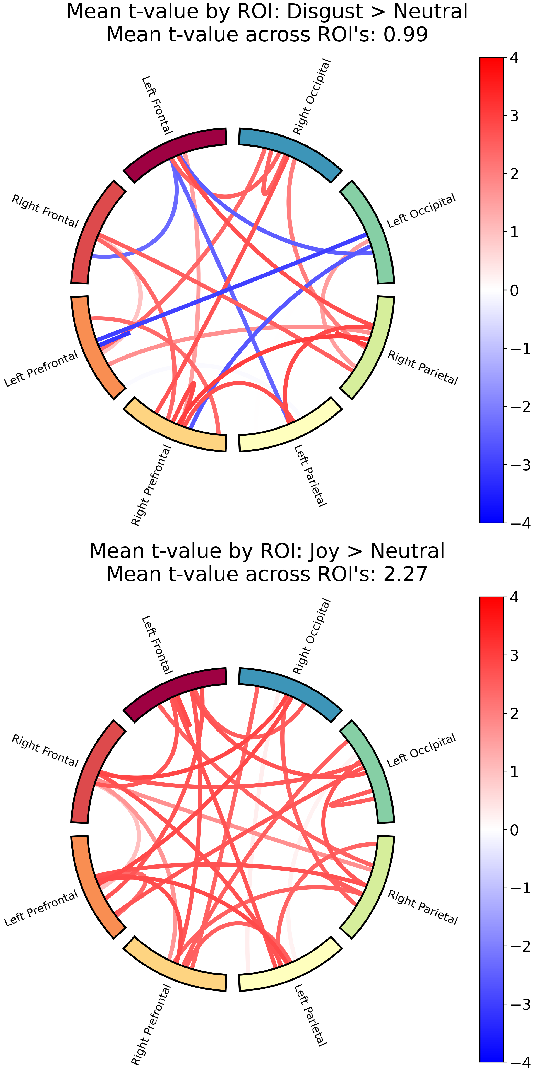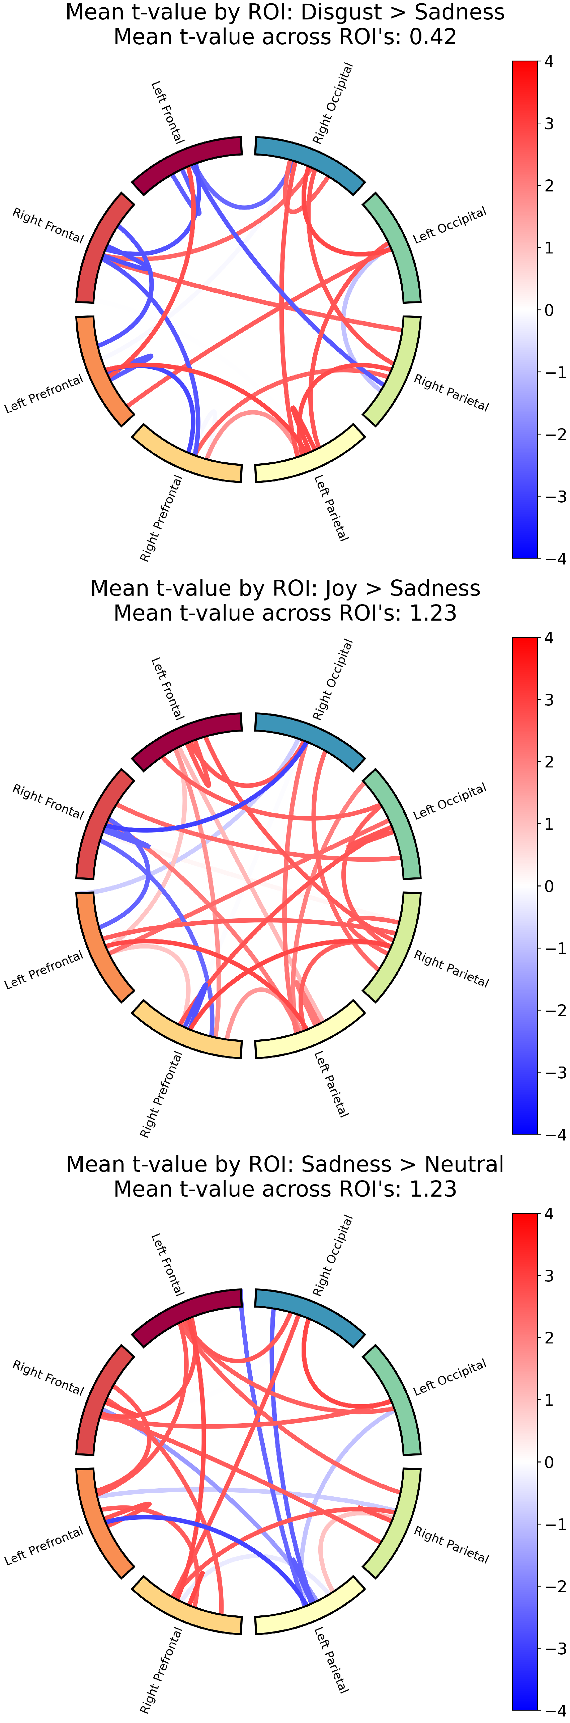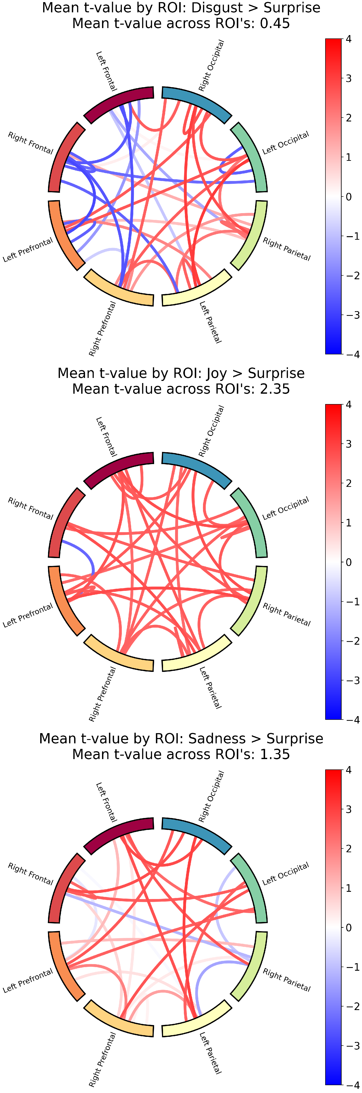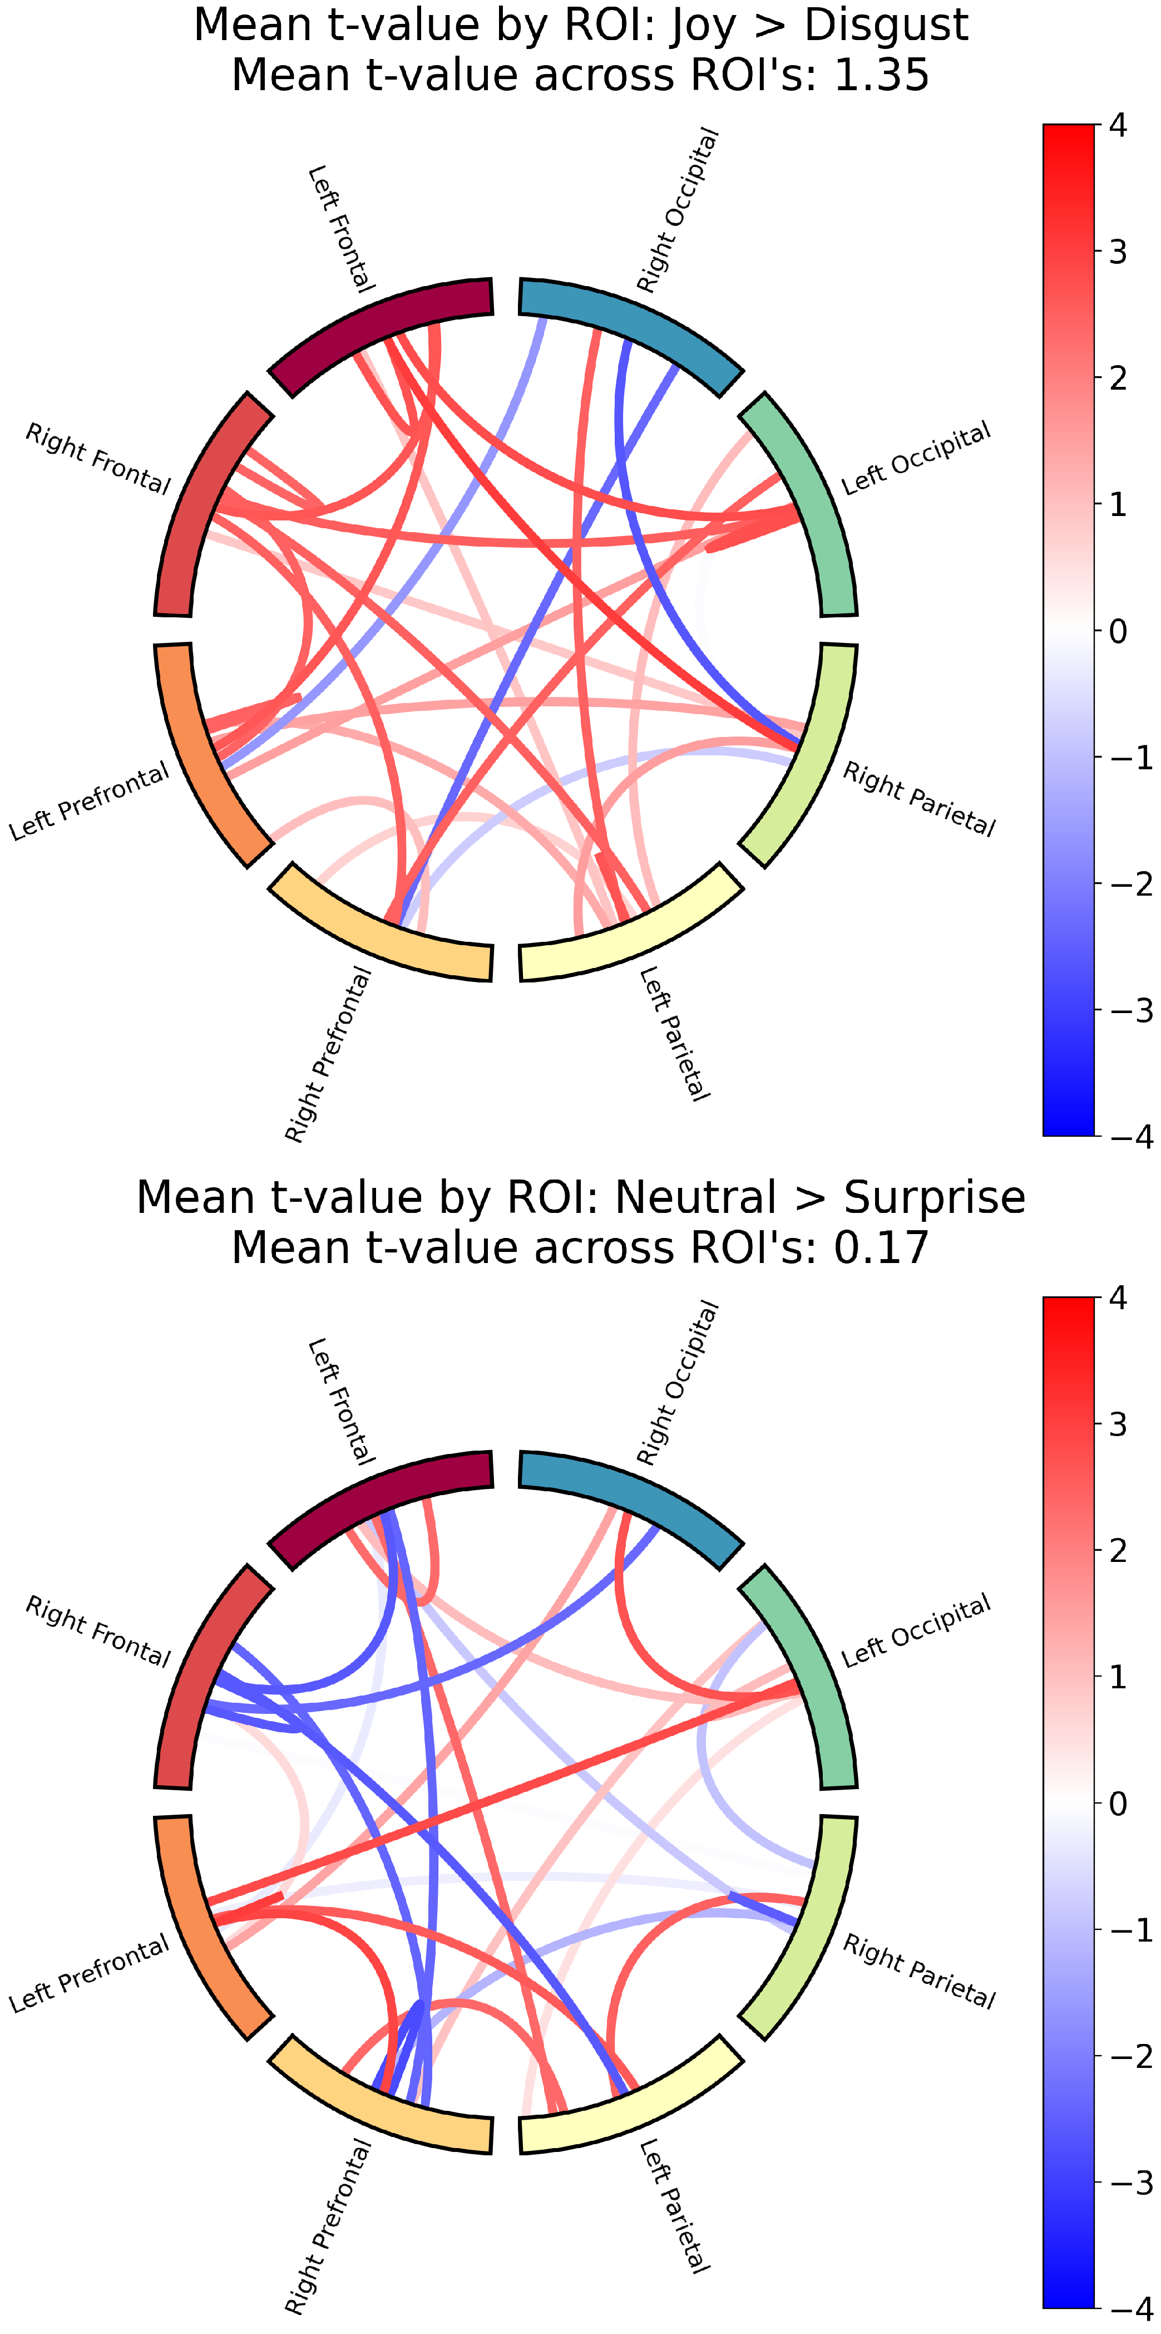

Figure B.1: Functional connectivity results for the rest of the contrasts. Same concept as explained in figure 3.6. These are the rest of the contrasts that were not shown in 3.7.

42

|  |  |  |
| --- | --- | --- |
| Real *>* Virt | 1.546 | 114.000 |
| Joy *>* Fear | -1.880 | 118.000 |
| Joy *>* Anger | -1.025 | 65.000 |
| Joy *>* Disgust | 1.354 | 135.000 |
| Joy *>* Sadness | 1.229 | 127.000 |
| Joy *>* Neutral | 2.269 | 113.000 |
| Joy *>* Surprise | 2.346 | 84.000 |
| Fear *>* Anger | 0.511 | 113.000 |
| Fear *>* Disgust | 2.382 | 196.000 |
| Fear *>* Sadness | 1.975 | 89.000 |
| Fear *>* Neutral | 2.615 | 263.000 |
| Fear *>* Surprise | 2.558 | 290.000 |
| Anger *>* Disgust | 1.929 | 164.000 |
| Anger *>* Sadness | 1.797 | 158.000 |
| Anger *>* Neutral | 2.565 | 185.000 |
| Anger *>* Surprise | 2.335 | 194.000 |
| Disgust *>* Sadness | 0.415 | 71.000 |
| Disgust *>* Neutral | 0.994 | 93.000 |
| Disgust *>* Surprise | 0.447 | 128.000 |
| Sadness *>* Neutral | 1.232 | 90.000 |
| Sadness *>* Surprise | 1.352 | 100.000 |
| Neutral *>* Surprise | 0.172 | 104.000 |

|  |  |  |
| --- | --- | --- |
| Real Joy *>* Real Fear | -0.243 | 109.000 |
| Real Joy *>* Real Anger | -1.058 | 97.000 |
| Real Joy *>* Real Disgust | 2.089 | 84.000 |
| Real Joy *>* Real Sadness | -0.986 | 154.000 |
| Real Joy *>* Real Neutral | 1.012 | 201.000 |
| Real Joy *>* Real Surprise | 0.676 | 124.000 |
| Real Joy *>* Virt Joy | 0.148 | 130.000 |
| Real Joy *>* Virt Fear | -2.114 | 136.000 |
| Real Joy *>* Virt Anger | -2.618 | 132.000 |
| Real Joy *>* Virt Disgust | -1.637 | 99.000 |
| Real Joy *>* Virt Sadness | 0.285 | 93.000 |
| Real Joy *>* Virt Neutral | 0.204 | 76.000 |
| Real Joy *>* Virt Surprise | 1.456 | 117.000 |
| Real Fear *>* Real Anger | -0.969 | 126.000 |
| Real Fear *>* Real Disgust | 1.906 | 119.000 |
| Real Fear *>* Real Sadness | 0.270 | 61.000 |
| Real Fear *>* Real Neutral | 1.413 | 167.000 |
| Real Fear *>* Real Surprise | 0.687 | 110.000 |
| Real Fear *>* Virt Joy | 0.371 | 129.000 |
| Real Fear *>* Virt Fear | -1.376 | 90.000 |
| Real Fear *>* Virt Anger | -2.352 | 167.000 |
| Real Fear *>* Virt Disgust | 0.075 | 78.000 |

|  |  |  |
| --- | --- | --- |
| Real Fear *>* Virt Sadness | 1.073 | 118.000 |
| Real Fear *>* Virt Neutral | 0.983 | 101.000 |
| Real Fear *>* Virt Surprise | 1.805 | 136.000 |
| Real Anger *>* Real Disgust | 2.054 | 158.000 |
| Real Anger *>* Real Sadness | 0.545 | 113.000 |
| Real Anger *>* Real Neutral | 1.915 | 191.000 |
| Real Anger *>* Real Surprise | 1.773 | 115.000 |
| Real Anger *>* Virt Joy | 1.931 | 141.000 |
| Real Anger *>* Virt Fear | -0.996 | 85.000 |
| Real Anger *>* Virt Anger | -1.887 | 70.000 |
| Real Anger *>* Virt Disgust | 0.840 | 103.000 |
| Real Anger *>* Virt Sadness | 1.050 | 134.000 |
| Real Anger *>* Virt Neutral | 1.744 | 109.000 |
| Real Anger *>* Virt Surprise | 1.377 | 217.000 |
| Real Disgust *>* Real Sadness | -1.856 | 106.000 |
| Real Disgust *>* Real Neutral | 0.347 | 124.000 |
| Real Disgust *>* Real Surprise | -0.980 | 130.000 |
| Real Disgust *>* Virt Joy | -0.600 | 96.000 |
| Real Disgust *>* Virt Fear | -2.206 | 146.000 |
| Real Disgust *>* Virt Anger | -2.606 | 284.000 |
| Real Disgust *>* Virt Disgust | -1.452 | 66.000 |
| Real Disgust *>* Virt Sadness | -0.670 | 121.000 |

|  |  |  |
| --- | --- | --- |
| Real Disgust *>* Virt Neutral | -0.843 | 83.000 |
| Real Disgust *>* Virt Surprise | -0.139 | 69.000 |
| Real Sadness *>* Real Neutral | 1.797 | 128.000 |
| Real Sadness *>* Real Surprise | 1.771 | 97.000 |
| Real Sadness *>* Virt Joy | 1.686 | 124.000 |
| Real Sadness *>* Virt Fear | -0.656 | 33.000 |
| Real Sadness *>* Virt Anger | -2.204 | 80.000 |
| Real Sadness *>* Virt Disgust | -0.303 | 56.000 |
| Real Sadness *>* Virt Sadness | 0.713 | 107.000 |
| Real Sadness *>* Virt Neutral | 1.475 | 47.000 |
| Real Sadness *>* Virt Surprise | 2.301 | 104.000 |
| Real Neutral *>* Real Surprise | -0.638 | 173.000 |
| Real Neutral *>* Virt Joy | -1.072 | 67.000 |
| Real Neutral *>* Virt Fear | -2.179 | 255.000 |
| Real Neutral *>* Virt Anger | -2.525 | 322.000 |
| Real Neutral *>* Virt Disgust | -2.123 | 139.000 |
| Real Neutral *>* Virt Sadness | -0.900 | 151.000 |
| Real Neutral *>* Virt Neutral | -0.988 | 102.000 |
| Real Neutral *>* Virt Surprise | 0.344 | 143.000 |
| Real Surprise *>* Virt Joy | 0.824 | 120.000 |
| Real Surprise *>* Virt Fear | -2.407 | 136.000 |
| Real Surprise *>* Virt Anger | -2.482 | 167.000 |

|  |  |  |
| --- | --- | --- |
| Real Surprise *>* Virt Disgust | -1.044 | 80.000 |
| Real Surprise *>* Virt Sadness | -0.182 | 73.000 |
| Real Surprise *>* Virt Neutral | 0.162 | 104.000 |
| Real Surprise *>* Virt Surprise | 0.883 | 88.000 |
| Virt Joy *>* Virt Fear | -1.810 | 166.000 |
| Virt Joy *>* Virt Anger | -2.421 | 189.000 |
| Virt Joy *>* Virt Disgust | -1.524 | 129.000 |
| Virt Joy *>* Virt Sadness | -0.185 | 118.000 |
| Virt Joy *>* Virt Neutral | -0.695 | 103.000 |
| Virt Joy *>* Virt Surprise | -0.287 | 80.000 |
| Virt Fear *>* Virt Anger | -1.766 | 51.000 |
| Virt Fear *>* Virt Disgust | 1.338 | 72.000 |
| Virt Fear *>* Virt Sadness | 1.757 | 125.000 |
| Virt Fear *>* Virt Neutral | 2.267 | 114.000 |
| Virt Fear *>* Virt Surprise | 2.356 | 153.000 |
| Virt Anger *>* Virt Disgust | 2.054 | 138.000 |
| Virt Anger *>* Virt Sadness | 2.488 | 170.000 |
| Virt Anger *>* Virt Neutral | 2.373 | 128.000 |
| Virt Anger *>* Virt Surprise | 2.616 | 207.000 |
| Virt Disgust *>* Virt Sadness | 1.327 | 74.000 |
| Virt Disgust *>* Virt Neutral | 1.005 | 39.000 |
| Virt Disgust *>* Virt Surprise | 1.471 | 153.000 |

|  |  |  |
| --- | --- | --- |
| Virt Sadness *>* Virt Neutral | -0.015 | 100.000 |
| Virt Sadness *>* Virt Surprise | 1.176 | 82.000 |
| Virt Neutral *>* Virt Surprise | 0.943 | 99.000 |

# Appendix C

**Memory Task ANOVA Table**

Table C.1: Two-way ANOVA results for the effect of Face Type and Emotion and their interaction on the correct responses.

Intercept C(Face Type) C(Emotion)

C(Face Type):C(Emotion)

Residual

sum sq

261.07756

1.17722

0.73335

0.40872

df

1.00000

1.00000

6.00000

6.00000

*F*

PR(*>F* )

1764.58989 0.00000

7.95666

0.82610

0.46041

0.00481

0.54946

0.83797

710.47356 4802.00000

49